International Marketing
Plan Guide

Compiled from plan developed by Insearch, University Technology Sydney and additional sources from Darren Paproski, Vancouver Island University
TABLE OF CONTENTS

Acknowledgments

Executive Summary. The Executive Summary should contain the following:
- Brief overview of the project objective (e.g. Lululemon Company is planning to develop the Indian market for its line of clothing by establishing its own network of stores in the key cities of New Delhi and Bangalore….)
- Highlight the main reason for market expansion.
- Briefly outline the key strategies to be used (e.g. entry, STP, 4Ps).
- Highlight forecasted revenue, profit, and other objectives (e.g. channel objectives)
- You may highlight other aspects that you feel pertain particularly to your product area.
- (NB: The Executive Summary is not an introduction to the paper (in your first or second paragraph in the introduction section (Section1.0) you can outline briefly the contents of the paper).

Table of Contents

List of Figures and Tables

1.0 Introduction
- Brief overview of the company, its main products, target country, main target markets, and primary entry strategy

2.0 Research Methodology (For reference purpose here)

3.0 Situational Analysis
3.1 Company Analysis
3.2 Organization’s Assets and Skills
3.3 Market Analysis
3.3.1 Business Environment analysis
3.3.1.1 Political/Legal/Institutional Environments
3.3.1.2 Regulatory Environment (Present and anticipated)
3.3.1.3 Economic Environment (Conditions and Trends)
3.3.1.4 Social and Cultural Environment (Factors and Trends)
3.3.1.5 Demographic Environment (Data and Identification of Trends)
3.3.1.6 Technological Environment (Factors and Trends)
3.3.1.7 Natural Environment (Effect of Seasonal or Climatic Factors)
3.3.1.8 Physical Environment (Infrastructure Indicators)
3.3.2 Nature of Demand
3.3.3 Size and Extent of Demand
3.3.4 Product Category Stage of Product Life Cycle
3.3.5 Structure of the Industry
3.3.5.1 Cost Structure of the Industry
3.3.5.2 Competitive Structure of the Industry
3.4 Competitor Analysis (in country of investment)

4.0 SWOT ANALYSIS
4.1 Internal Company Strengths and Weaknesses
4.2 External Market Opportunities and Threats
4.3 Implications of SWOT Analysis

5.0 OBJECTIVES → should follow from SWOT
5.1 International Objectives
5.2 Market Objectives

6.0 RECOMMENDED MARKETING STRATEGY (TSP Framework)
6.1 Target Markets Identification and Segmentation Strategy
6.2 Market Positioning
6.3 Market Entry Strategy

7.0 MARKETING MIX STRATEGIES AND TACTICS
7.1 Product/Service and Branding Strategy
7.2 Place (Distribution) Strategy
7.3 Price Strategy Structure
7.4 Promotion Strategy (including Promotional Budget)

8.0 PLANNING BUDGET
8.1 Planning Assumptions
8.2 Forecast Sales (and Market Share) and Costs (Capital, Operating, Marketing, etc.)
8.3 Forecast Profitability (or Break Even Analysis)
8.4 Sensitivity Analysis (incorporating contingency issues)

9.0 IMPLEMENTATION AND CONTROL
9.1 Formal Project Plan for Implementation of Recommendations
9.2 Monitoring of Action Plan
9.3 Formal Contingency Plans

10.0 BIBLIOGRAPHY/REFERENCES

11.0 APPENDICES
11.1 Situation Analysis
11.2 SWOT Analysis
11.3 Evaluation of Alternative Marketing Strategies (where applicable)
11.4 Company promotional/product brochures (where applicable)
11.5 Tariff Rates
11.6 Summary Table of interviews (where applicable)
11.7 Record of Contact and Activities, and Project Plan (where applicable)
11.8 Other appendices you feel appropriate

THE MARKETING PLAN

This report (or guide) has been written as an aid to developing an international marketing plan. It is divided into a number of key sections that are a suggested framework for your plan.

The guide is a generalized approach to writing an international marketing plan. Each section identifies many key issues that can be addressed in the preparation of such a plan.

Not all the issues are relevant to each company's case. Also, additional issues may arise that are not covered in this guide. You will, however, find it a useful tool in tackling many of the questions that do arise.

It can be used to document an approach for new market entry or existing market expansion. A key assumption is that only one new country market will be considered at a time.

The guide is relevant to marketers of both products and services. For simplicity, however, the term "products" is used throughout.

Planning is an essential part of developing a successful international business. It is a process that examines a firm's business in relation to:
- Where it is now
- Where it wishes to go
- How it can get there

Generally it follows the process of:
- Company and market assessment
- Generation of achievable objectives
- International strategy development
- Evaluation of alternative marketing strategies
- Operational programs to support the strategy

The plan is principally of benefit to the company's managers and current or potential owners of the business. It is a document prepared at a point in time that should describe a clear and concise series of activities that will achieve a particular international marketing objective, in line with the selected marketing strategy.

DO NOT fill your marketing plan with a lot of irrelevant information. All information contained in the report must be analyzed and related back to the company and the new market.

Remember: The plan must be action oriented!

2.0 RESEARCH METHODOLOGY (For reference purposes here)

You must provide details of the type of methodology you employed for this report. Ideally, you should conduct extensive secondary research and then obtain further, more tailored/specific information from primary sources. The primary data can be analyzed using either quantitative or qualitative methodology or a combination of both.

Full details of your methodology should be provided in an appendix (e.g. Summary Table of Interviews, which will describe part of your methodology in terms of respondents).

SECTIONS 3.0, 4.0 AND 6.0 (See Appendix 11.1)

Sections 3.0, 4.0 and 6.0 in the Main Report should contain a summary of the main points of the Appendices.

Although there is no clear cut formula for incorporating material from the Appendices in the main report, some sections (SWOT Analysis and Alternative Marketing Strategies) will contain almost all of the Appendix material in the equivalent section of the Main Report, while other sections (Situation Analysis) will be abbreviated in the Main Report - but with sufficient content to clearly
address the key questions and issues related to that section. You can, if you wish, abbreviate the Appendices in the Main Report and reference material back to the Appendices. In all cases, in the Main Report, you must clearly reference the appendix material.

3.0 SITUATION ANALYSIS

This section will contain the results of your analysis of the information contained in Appendix 11.1.

4.0 SWOT ANALYSIS

The data gathered together in Appendix 11.1 and clearly stated in section 3.0 Situation Analysis now needs to be analyzed in order to assess the market opportunities in relation to the likely barriers to market entry or expansion.

The strengths, weaknesses, opportunities and threats should be clearly laid out in your report. It is often best to present the SWOT in a table, either in the Main Body or in the Appendix.

It is vital that you analyze the information in the SWOT analysis and discuss the implications for your company in the new market. The implications should be stated in the main body of your report.

Figure 1 - The SWOT Analysis (See also Appendix 11.3)
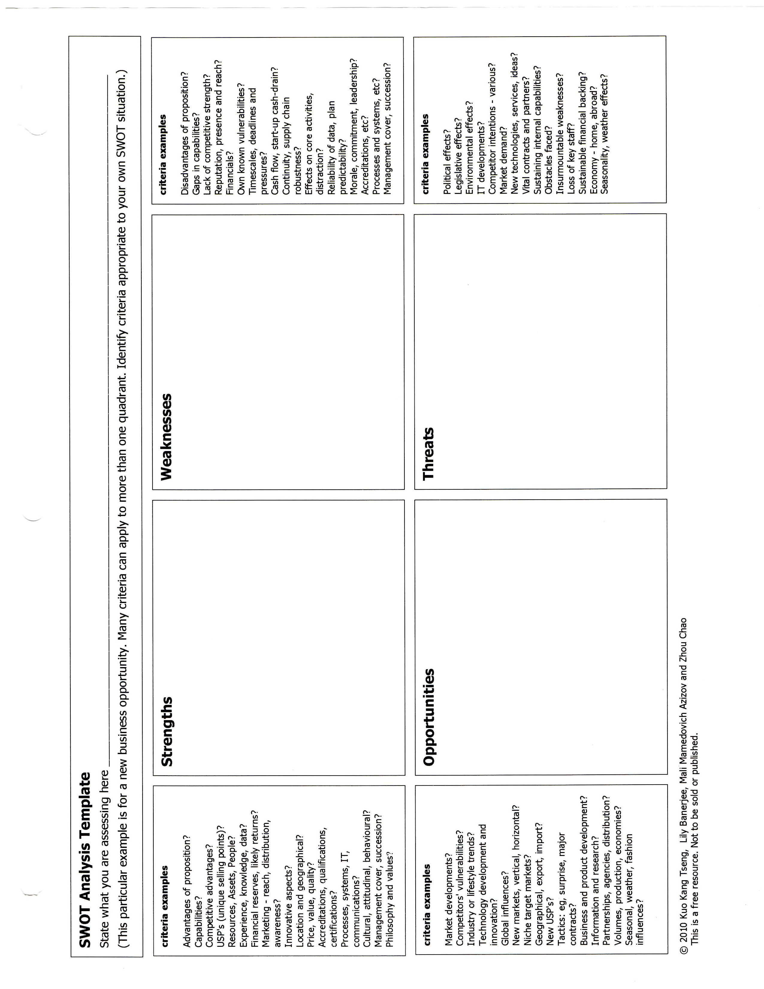
5.0 OBJECTIVES

5.1 International Objectives

Why is the company seeking to expand internationally?
- Seeks growth via international business
- Will improve cost position through economies of scale
- Market diversification etc.?

5.2 Market Objectives

The first market objective a company may define for a particular overseas market is which market segment(s) should the firm focus its limited resources on.

This targeting is required because companies usually cannot satisfy the needs and requirements of each segment equally well. From an examination of these different needs, it will become apparent which products and services within the company’s portfolio will be the most attractive to these market segments.

The company can also define its objectives in terms of how its market share after a given time will compare to its competitors, for example:
- Market leader
- Market follower, etc.

A key consideration is where can the company’s marketing effort yield the greatest return? In other words, where is Return-On-Investment (ROI) highest?

The company should define its market objectives, in line with the key issues for international expansion, as identified in section 3.0 Situation Analysis. Often, objectives will be defined in terms of quantity (volume of units) or value ($) of goods sold over a given time period.

Financial objectives follow from the above analysis. Marketing programs must ultimately be funded from cash flow generated within the market, with profits being used by the company for:
- Repatriation to shareholders
- Funding further growth
- etc.

A number of profit analyses can be used:
- Contribution analysis
- Break-even analysis
- ROI analysis, etc.

All of these analyses (quantity/value objectives, profitability objectives) should have a time frame:
- Short-term (1 - 3 years)
- Long-term (4 - 5 years and longer)

Objectives should be S.M.A.R.T. (specific, measurable, achievable, realistic, time-specific) wherever possible.

6.0 RECOMMENDED MARKETING STRATEGY

The recommended marketing strategy is a result of the analysis in Appendix 11.3: Evaluation of Alternative Marketing Strategies.

Remember that if you decide not to proceed with market entry or expansion, this can also be a reasonable strategy option.

Target markets and positioning statements should be clearly identified. Often it is useful to clearly define a positioning strategy in a single sentence which summarizes in a general way what the company seeks to achieve and how it will do it. For example:

"We will achieve market leadership by providing quality ergonomic furniture solutions to architects that best meets their needs and requirements."

An important positioning characteristic of a brand - whether a car, a soft-drink, a bicycle or a computer - is its position on the perceived quality dimension. Is it an economy, value, premium or ultra premium entry? In addition, with regards to a perceived quality category, is the brand the best, or is it merely competitive with other brands in the same class?

"To discerning people who want the best, Mercedes is the car that will give you the benefits of the latest technology combined with safety and power, offering maximum reliability and state-of-the-art quality".

Entry Strategy

When a company makes the commitment to go international, it must choose an entry strategy. This decision should reflect an analysis of market characteristics (such as potential sales, competition, strategic importance, strengths of local resources, cultural differences, and country restrictions and deregulation. In addition, company capabilities and characteristics, including the degree of near-market knowledge, marketing involvement, and commitment that management is prepared to make must be considered.

Companies most often begin with modest export involvement. A company has four different modes of foreign market entry from which to select: exporting, contractual agreements, strategic alliances, and direct foreign investment. The different modes of entry can be further classified on the basis of the equity or non-equity requirements of each mode. The amount of equity required by the company to use different modes affects the risk, return, and control that it will have in each mode.

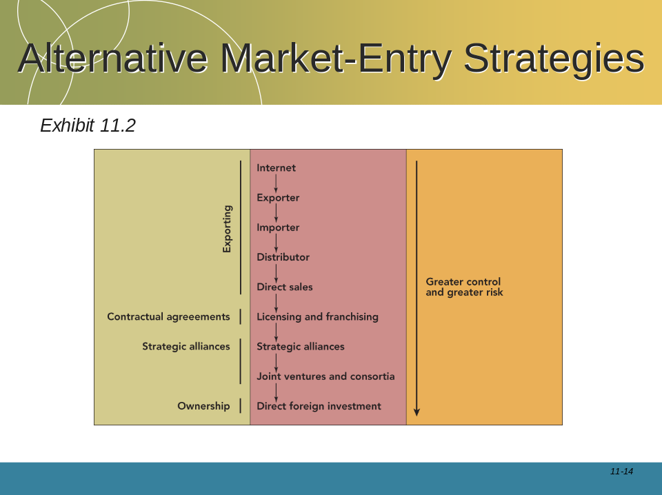

7.0 MARKETING MIX STRATEGIES AND TACTICS

Break each of the 4 Ps into Strategy and Tactical Plan elaboration. You need to provide a lot of detail, particularly in the Tactics component. The marketing mix strategies and tactics must be integrated and consistent to achieving company objectives.

How product, promotion, distribution, and pricing strategies evolve in international marketing is dependent on the approach to internationalization the company takes. Therefore, you need to consider your marketing mix strategy in light of your market entry strategy addressed in Section 6.

Differing strategies and market tactics may be required for various target segments. For a given target segment, alternative strategies and programs should be formulated and evaluated as to the effectiveness of each in achieving company objectives.

Some of the issues that might be relevant include:

7.1 Product

Make sure that product strategies support the company’s overall strategy.
- Modify existing product(s) - (what features and benefits will your
- products provide?)
- Develop new product(s)
- Add or drop products from the line
- Determine product positioning relative to key competitors
- Develop branding approach
- Register product designs, brand name, trademarks, etc.
- Tailor product packaging and labeling to the market
- Initiate product registration

7.2 Price

A number of issues are important in pricing products for overseas markets:
- How will product price be determined (demand-based or cost-plus, marginal costing or full costing)
- Price level compared to competitors (premium, parity or discount)
- Price variation (geographic margins, discount structure)
- Margins that will be offered to local partners such as agents, distributors, etc.
- Penetration pricing, market skimming etc.
- Terms of sale (CIF, FOB etc.)
- Terms of payment (cash in advance, letter of credit, etc.)

7.3 Distribution

A number of distribution options are likely to be available to your company. You will need to assess the distribution (and production) options in accordance with the opportunities available and the resources of the company. These may include:
- Direct export of branded products
- Indirect export of branded products
- Joint venture with a local partner with a shared market development responsibility, and possibly a shared manufacturing responsibility
- License technology to a company already established in the market (Manufacturing Under License, or MUL)
- Establish market franchises
- Purchase or establish your own means of distribution in the targeted country

You must decide whether you are going to use single or multiple channels.

Identify potential partners for the company (distributors, agents, joint venture partners, etc.) based on the chosen production/distribution option and profile according to important selection criteria such as:
- Established company with proven track record of business success
- Sales and marketing expertise and extent of geographical distribution/network coverage
- Access to funds to support and sustain market entry for the company’s products
- Personal contact in each of the targeted end-user segments
- High profile/integrity/good reputation, as perceived by end-users
- Complementary products manufactured/distributed
- Technical competence/ability to communicate to end-users
- Geographical extent of market coverage
- Other criteria which end-users may consider to be important
- Extent of interest in locally representing the Local country company

Having decided on one or more local partners, you must decide whether to negotiate exclusive or non-exclusive distribution arrangements with them.

7.4 Promotion

In order to promote your products and your company you must consider a number of major issues:
- Overall communication message that is suited to the local culture
- "Pull" or "Push" approach
- Type of promotion (personal selling, point-of-sale promotions, direct mail, etc.)
- Media to be used (radio, television, print, etc.)
- Use of Social Media platforms such as Facebook, Youtube, Twitter, LinkedIn, and others peculiar to that market, etc.
- Branding (family versus individual; possible cooperative branding)
- Trade promotion alternatives (what marketing communications activities will support the trade, if applicable)
- Dealer incentives
- Trade shows, conferences, etc., in which you will participate
- Communication approach: Extension vs. Adaptation
- Must the specific advertising message and media strategy be changed from region to region or country to country? What are the arguments for each?
- Global Choices with respect to advertising messages:
  - Prepare new copy for foreign markets in host country’s language
  - Translate the original copy into target language
  - Leave some or all copy elements in home country language

8.0 PLANNING BUDGET

The recommended cost of a marketing program is subject to serious consideration and approval by management.

Establishing the marketing budget is related directly to the preceding planning activity..... Strategies and Tactics. It must, of necessity, follow development of your action programs.

→ Strategies propose your plan of attack.
→ Budget specifies how much it will cost.

8.1 Planning Assumptions

Assumptions are estimates of future operating conditions for your marketing plan.

Assumptions describe your estimate of important developments or environmental conditions beyond your control....which you cannot accurately predict, but you must contend with as you carry out your plan.

8.2 and 8.3 Forecasts

All analyses and forecasts should be based on a multi-year format, usually covering a three to five year time-frame.

Forecasts should be presented in the form of Profit and Loss Statements for each year of the Plan, ideally with the 3 or 5 years of P & L statements rolled up into one table.

Forecasts should be as realistic as possible - even if this means that there may be losses.

The Profit and Loss Statements should include Break-Even Analysis.

8.4 Sensitivity/Scenario Analysis

This should be your "Most-Likely" Scenario. You should model two further scenarios - a "best-case" and "worst-case" scenario, clearly identifying your changes and assumptions in each scenario and using the same structure and time periods as in the "Most-Likely" scenario.

A table summarizing the P & L Statements for all scenarios should be presented in this section.

9.0 IMPLEMENTATION AND CONTROL

This section pulls together all the tactics and actions required for the successful implementation of the market entry/expansion program.

Control activities are directed towards programs initiated by the marketing process.

As the market process is based on implementation, it is necessary to state the way in which the marketing activities will be monitored and their outcomes measured. This will indicate whether the marketing objectives are being achieved.

You will need to:
- Establish standards
- Measure performances against standards
- Correct deviations from standards

Typically, control measures will be based on sales volume, sales value, or marketing contribution over a period of time. Measures may also be based on the number of distribution points obtained, quantity of floor stock placed, level of consumer awareness, change in consumer attitudes, amount of brand switching, or other measures that are appropriate and relevant.

You must also establish where decision making control will lie. Considerations of where decisions will be made, by whom, and by which method, constitute a major element of organizational strategy. Management policy must be explicit about which decisions are to be made at corporate headquarters, which at international headquarters, which at regional levels, and which at national or even local levels. Most companies also limit the amount of money to be spent at each level. Decision levels for determination of policy, strategy, and tactical decisions must be established. Tactical decisions normally should be made at the lowest possible level, without country-by-country duplication.

You should also develop contingency programs in case things do not go according to your plan.

9.1 Formal Project Plan for Implementation of Recommendations

Often a planning chart is used with a time span of about one year. A GANTT chart could be used, if you like. This chart is a guide to the implementation of the marketing plan and includes:
-Activity or action
- Key people/groups responsible for each activity
- Estimated commencement and completion dates
- Estimated costs

9.2 Monitoring of Action Plan

A review process should be formulated and presented and incorporated into the project.

9.3 Formal Contingency Plans

Contingency Plans should be included, clearly identifying contingency events and actions required to respond to these events. These plans may be in discussion form or in the same form as the Action Plan.
11.0 APPENDICES

The Appendices allow you to include useful information without disrupting the development of your argument in the body of the report with copious data.

APPENDIX 11.1 SITUATION ANALYSIS

11.1.1 Company Analysis

Briefly detail how the company is structured:
- Publicly or privately owned
- Main shareholders
- Associated organizations
- Key departments and their relationships
- Number of employees

When was the company established?

What is the core business activity of the company? What industry are you in and what are the major industry trends in Local country and overseas? What is your target market segment(s) in Local country? Who are your important customers?

What are the company’s operating revenues for the past three years?

Fully describe the company’s products/services in terms of:
- Breadth of product range (i.e. wide or narrow)
- Product features
- Product benefits
- Product applications
- Approximate contribution to venue of major product lines

Who are the key managers? What are their skills and experiences and how does this relate to the success of the venture?

What R & D activities does the company conduct? What percentage of revenue is spent on R & D?

What is the status of the company’s current technology (ideas, prototypes, etc.)?
What patents/copyright or trademarks does it hold?
What competing companies have technologies that are superior or equal to yours?

Describe the company’s domestic market position:
- Market leader
- Market follower etc.

Who are its main local country competitors? Are the major competitive products manufactured locally or overseas? What is the company’s and its competitor’s respective market share?

Does the company have access capacity for export (if relevant)? How might this be expanded? What are the critical product components and will there be problems in sourcing supplies?

What are the financial resources of the company?
- Does it have the funds available to support an effective market entry/expansion programme overseas?
- Where are the funds coming from and when will they be available?
- How accessible are the funds and would they be available for an export initiative?
- What are the company’s limits on funding overseas initiatives?

11.1.2 Organization’s Assets and Skills

What competitive strategy has brought the company to its present market position? What key competitive advantages underpin this strategy?

What are its 'Distinctive competences', 'unique selling proposition' or 'competitive edge'? What are the chief factors that will account for its international success? Are these strengths likely to be sustainable in international markets?

What is it about your products/services that would encourage a potential customer to switch from their existing supplier to your firm?

How are your products differentiated? What strengths/advantages do they have? What is the company’s cost position (is it a low cost producer)?

Do you offer superior service/support to end-users and channel intermediaries?

What is the company’s image/reputation in the marketplace?
- Winner
- Good copier
- Market innovator?

What production or operating advantages does the company have?
What is the state of production facilities?
Are the equipment/manufacturing methods used state-of-the-art?

Does the company have a competitive advantage in terms of its personnel – key executives, managers, sales personnel, etc.?

- Marketing skills (specific human marketing resources, corporate culture oriented toward marketing, ability to attract good marketers).
- Market research capabilities (and databank of information)
- Information technology and telecommunications capability
- Relationships with suppliers
- Relationships with distributors
- Relationships with media
- Relationships with key customers
- etc.

11.1.3 Market Analysis

A successful international market strategy requires identification of an attractive overseas market and establishment of a competitive position within that market.
Accurate market analysis is essential for these tasks.

Before analyzing the market, you should provide some rationale as to why you have chosen a particular country for investigation. Also describe what selection criteria was used.

11.1.3.1 Business Environmental Analysis

What are the main environmental factors influencing market demand for the relevant product category, and therefore the company’s operation in the country.

11.1.3.1.1 Political/Legal/Institutional Factors

List factors relevant to your company’s activities/products within that country.
Include:
- What is the country's geographical, political and legal proximity to local country?
- What is the level of political stability in the country?
- How will the various elements of environmental climate be likely to impact on the demand for the company's products?
Are there any expected legislative changes that will impact on your market entry?

11.1.3.1.2 Regulatory Environmental Factors (Present and Anticipated)
Are there are specific relevant regulations related to your product with respect to product testing, safety standards, advertising restrictions, zoning or bylaw restrictions? Are any of the current regulations likely to change?

What tariff and non-tariff barriers exist for imported products?
- Duty rates?
- Quotas

Do these barriers differ for local and non-local manufactured products?

Are there any restrictions on remitting licensing and royalty fees overseas?

What standards and regulations are applicable to these products?
What are the certification requirements?

To what extent do the regulatory standards govern manufacturing, promotion, labeling, packaging, distribution and pricing?

Who are the major regulatory authorities? Provide details of who should be approached for product registration.

Outline the registration/certification process. What are the typical registration delays and costs for this product category?

11.1.3.1.3 Economic Conditions

Provide a brief economic overview with an assessment of the following economic indicators:
- Population size
- GDP
- Current and forecasted economic growth
- Inflation rate
- Unemployment
- Interest rates (base lending rates)
- Disposable incomes
- Other relevant indicators

11.1.3.1.4 Social and Cultural Factors

Provide information on any social and culture factors that will impact on your firm's activities/products within that country.
Include:
- What is the country's cultural and language affinity with local country?
- Level of entrepreneurial spirit
- Attitudes (e.g. health, environmental consciousness, etc.)
- Leisure interests
- Any social trends that you may be able to take advantage of?
- you may apply Hofstede's updated 6-D Analytical Model (see example below)
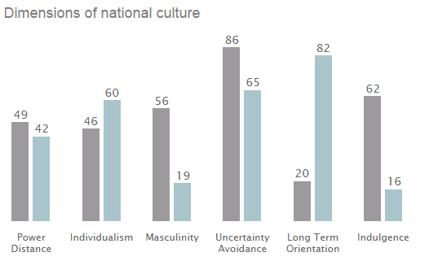

11.1.3.1.5 Demographic Trends

List all relevant demographic trends in the target overseas market (age distribution, per capita income, level of education, socio-economic groupings, etc.)

11.1.3.1.6 Technological Environment and Trends
List all relevant technological factors that aid or inhibit product or service delivery or relationships with buyers or suppliers. Technological factors may also have implications for the type of promotional media used. For example, does your target market have access to television, internet, mobile phones, etc. Are there any trends in accessibility and how might they affect your company.

- Recent technological developments
- Technology’s impact on product offering
- Impact on cost structure
- Impact on value chain structure
- Rate of technological diffusion
- Government research spending
- Industry focus on technological effort
- New inventions and development
- Rate of technology transfer
- Life cycle and speed of technological obsolescence
- Energy use and costs
- Changes in information technology
- Internet
- Mobile technology

11.1.3.1.7 Natural Environment (Effect of Seasonal or Climatic Factors)

Only include details that impact on your company's activities in the target country, in terms of supply, storage, distribution, demand, etc.

11.1.3.1.8 Physical Environment (Infrastructure Indicators)
- Number of airports (including freight facilities at airports)
- Number of ports and types of facilities
- Length/quality and facilities of the rail network
- Quality of road network
- Description of telecommunications, media and information technology environment
- Degree/percentage of urbanization
- Level of literacy
- Number of telephones/radios/televisions/cars/computers/daily newspaper circulation

11.1.4 Nature of Demand

Can the market be meaningfully segmented or broken into homogeneous groups of buyers? Identify these major end use segments. Criteria for segmentation may include:
- Age
- Geographic location
- Psychographic characteristics
- etc.

For each of the key market segments (consumer and industrial) you identify, provide information on buyer characteristics such as:
- Key participants
- Degree of concentration/geographic dispersion of target consumers
- Level of overt information seeking
- Degree of brand awareness and loyalty
- Location of product category decision (i.e. home or point of sale)
- Sources of product information and current awareness/knowledge levels
- Duration of the decision process (repeat, infrequent, new purchase)
- Level of buyer interest and involvement in the purchase decision
- Risk of uncertainty of negative purchase outcome
- Time and location of consumption

What is the major method of procurement in each segment?
- Public tender
- Purchase in retail outlets
- etc.

Who specifies, initiates and influences the purchasing decision in each market segment?

Identify and rank in order of importance the key considerations affecting the purchase decision in each segment and provide a brief explanation of each criterion. These may include:
- Product features/benefits
- Uniqueness of design
- Price
- After-sales support
- Ease of use/training required
- Reliability
- Brand/corporate reputation of supplier
- Speed of supply/availability
- Level of customization
- Payment terms
- Preference for locally manufactured goods
- Personal relationships between buyer and seller
- Other

How are customers likely to respond to the company's product/service offerings?

You may also use the 6W model of The Customer Environment
- Who are the current and potential customers?
- What do customers do with our products?
- Where do customers purchase our products?
- When do customers purchase our products?
- Why (and how) do customers select our products?
- Why do potential customers not purchase our products?

11.1.5 Size and Extent of Demand

What is the size of the market? What are the total sales figures for the relevant product category over the past three years, and projected sales:
- By volume (i.e. units)
- By value (i.e. $)

What are the major factors influencing any changes in product sales? What is driving these sales trends in this market?

Provide a breakdown of the above historical and forecasted sales figures for each of the major end-user segments (best estimates will suffice if statistical data is not available).

Is the proportion of sales to each of these segments changing? If so, what are the likely reasons for these changes?

What is the size of the import market? Provide import statistics for the past three years, and projected imports:
- By volume (i.e. units)
- By value (i.e. $)

Is the import market growing/declining/static as a proportion of the total market? Why?

11.1.6 Stage of the Product Life Cycle

For this product group, will the effectiveness of marketing variables differ by stages of the product life cycle?

What is the stage of the product life cycle? What are your reasons for your assessment? Are there apparent changes over time in the types of products demanded? How long has the technology/product been established?

What is the extent and duration of acceptance by end-users?

What is the state of the buyer's knowledge of the product category?

11.1.7 Cost Structure of the Industry

What are the cost factors in production, marketing and distribution in terms of the cost of?
- Raw materials or components
- Tariffs and other barriers
- Land or factory space
- Labor
- Electrical power
- Insurance
- Meeting local quality standards and regulations
- Packaging
- Transport
- Warehousing

How do these costs compare to those of foreign suppliers, particularly local suppliers? Are local manufacturers/suppliers at a cost advantage or disadvantage?

What are the average margins and price levels through the distribution channels (i.e. from manufacturer, wholesaler, retailers, etc.)?

11.1.3 Competitor Analysis

What percentage of the market is supplied by:
- Locally manufactured products
- Imported products?

Is the country a net importer or a net exporter of this product group? Which countries are the major foreign suppliers to the market? What is their market share?

Who are the major competitive manufacturers/suppliers (overseas and locally based) of these products?

Is the competitive environment fragmented or concentrated? What is the number of competitors (5 versus 500)?

Identify and rank in terms of market share the major local and overseas manufacturers/suppliers and provide the following information:
- Ownership
- Other businesses they are active in
- Location of production
- Products manufactured (type, strengths/weaknesses, patented features, etc.)
- Comparative size (turnover figures)
- Market segments they are most active in. Why?
- Business strategies employed (basis of differentiation or low cost strategy)
- Method of distribution/type and identity of local representatives (agents, distributors direct to end-users, etc.)
- Pricing structure (retail, wholesale, distributor margins offered, etc.)
- Financial, production and marketing resources and skills
- Reputation amongst customers

Assess the relative threat that your company represents to these competitors.
What will be their likely retaliatory reaction to your market entry?
Can they neutralize different marketing programs you might develop?

What substitute products are in use and which companies supply them?

11.1.3.1 Competition Analysis
We can categorize four basic types of competition:
- Brand competitors
- Product competitors
- Generic competitors
- Total budget competitors
APPENDIX 11.2 SWOT ANALYSIS

A tool that is commonly used to assess the market opportunities in relation to the likely barriers to market entry or expansion is the "SWOT" analysis. This is a business assessment made from a review of the overseas market (external factors) and the company (internal factors).

The SWOT refers to the:

11.2.1 Strengths and Weaknesses of your firm and its products/services (in comparison to competitors), and an analysis of:

11.2.2 Opportunities and Threats in the overseas marketplace.

Figure 1 in the Main Report considers the main elements of the SWOT analysis.
Strengths  - Identify the company's strengths  - relative to those of its competitors.  - What are the characteristics of the company's product/service offering that are not generally matched by competitors?  The Company | Weaknesses  - Identify the company's weaknesses relative to those of its competitors.  - What are the characteristics of the company’s product/service offering that are not generally equal to its competitors?  (Internal) (11.1.1)
The Market  Opportunities  - Identify the trends and actions external to the company which may provide opportunities.  - These market opportunities may be current or emerging.  - What is the nature and extent of these opportunities in the target market and what are the consequences for the company? | (External) (11.1.2)  Threats  - Identify the trends and actions external to the company which may create threats.  - These market threats may be probable or possible.  - How likely are these threats in the target market and what are the consequences for the company?

11.2.3 Implications of SWOT Analysis

Based on the company and market investigations, provide an assessment of the firm's likelihood of success, taking into account the opportunities and problems highlighted by the SWOT.

You must answer the question: should the company attempt to enter or expand its activities in the targeted country?

The critical issue is whether a profitable business can be established and maintained in the targeted international market.

This is dependent on whether the company has, or can develop, a competitive advantage that is sustainable in that market.

SWOT analysis must be customer-focused.
- How do the identified strengths enable the company (industry) to meet customer’s needs? How do these strengths differentiate the industry from competitors?
- How do any weaknesses prevent the company (industry) from meeting customers' needs? How do these weaknesses negatively differentiate the company from competitors?
- Assessment of opportunities will answer the questions:
1. How are these opportunities related to serving customer needs?
2. How can the company catch and keep the opportunities?
- How are these threats related to serving customer needs?
- How can the company (industry) prevent these threats from limiting its capabilities?

SWOT MATRIX

After the elementary study of SWOT analysis, strengths, weaknesses, opportunities and threats can be identified. The next step is to study how to convert the bad side to the good one. In this step of the SWOT analysis, strengths of companies should be used to match opportunities, weaknesses should be converted to strengths, and threats should be transformed to opportunities. The figure below illustrates the theory proposed by Ferrell and Hartline (2005).

SWOT Matrix
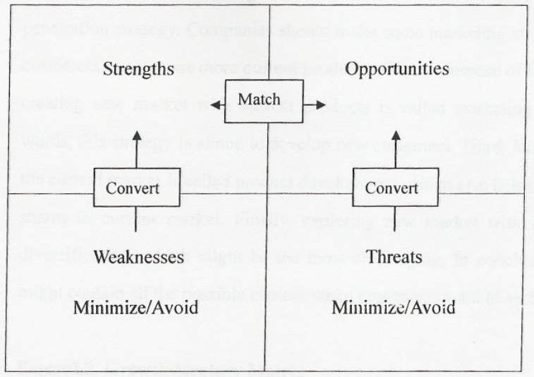
(Source: Ferrell and Hartline, 2005)
11.2.4 Summary flow of analytical frameworks.

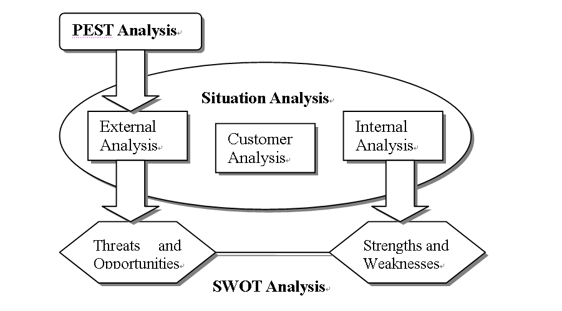
The main analytical frameworks used are PEST, Situation, and SWOT Analyses. PEST analysis emphasizes the macro- environment of the target market, which studies four aspects, Political, Economic, Social, and Technological factors. The situation analysis provide a clear background of the company stated as internal analysis, customer environment, as well as external analysis. SWOT analysis is used to assess strengths and weaknesses of the company and its products and services, and opportunities and threats in the marketplace. All three analytical frameworks together provide comparatively comprehensive understanding and perspectives to the manager and fully examine the feasibility from the internal environment to external, from customers to the company, from weaknesses to strengths.
APPENDIX 11.3: EVALUATION OF ALTERNATIVE MARKETING STRATEGIES

A thorough examination of all marketing strategies that should be considered by the organization is included in this section. Each of these strategies needs to be evaluated in terms of advantages and disadvantages, leading to a recommendation of either accepting or rejecting the strategy. The main focus in the main body of the report will, of course, be on the recommended strategy(ies).

Many companies attempt to extend their domestic (i.e. Local country) strategy to international markets. This may or may not be successful, depending on the similarities of customers at home and abroad, as well as similarities in competitive offerings.

Appendices 11.4, 11.5, 11.6 Put here if applicable

APPENDIX 11.7: RECORD OF CONTACT AND ACTIVITIES, AND PROJECT PLAN
(NB: This section is not applicable for MBA 523)

The following appendices must be completed in the Progress Report as fully as possible as they may be used as a measurement of individual involvement in the project and therefore considered in the individual's final project mark:

- PROGRESS RECORD OF CONTACTS AND ACTIVITIES
- PROGRESS INTERNATIONAL MARKETING PROJECT PLANNING CHART WITH FORECASTS FOR ACTIVITIES TO BE COMPLETED IN THE PROJECT

For more detail on various aspects of Situation Analysis see www.netmba.com.
Ferrell, O.C. and Hartline, M.D. (2005), Marketing Strategy, 3rd ed., Mason, Ohio: South-Western, p.47
Ferrell and Hartline, 2005
See Ferrell, O.C. and Hartline, M.D. (2005) Marketing Strategy 3rd edition, Mason, Ohio: South-Western.

