Table 1 Sectoral and National Equity Indexes
 | Bahrain |  | Kuwait |  | Oman |  | Qatar
Sample: | 6/30/2004 - 12/31/2010 |  | 3/31/2002 - 12/31/2010 |  | 1/6/1999 - 12/31/2010 |  | 5/14/2001
 | Dow Jones^{N} (GG, 0.03) |  | MSCI Kuwait^{N} (GG, 0.04) |  | Muscat^{N} (G, 0.09**) |  | Banking & Financial (0.07**)
 | Commercial Banks (G, 0.05**) |  | Banks (-0.03) |  | Banking & Investments (G, 0.11**) |  | Insurance (G, 0.10**)
 | Hotel & Tourism (-0.03) |  | Food (-0.01) |  | Services & Insurance  (G, 0.10**) |  | Industrial (G, 0.06**)
 | Industry (-0.01) |  | Insurance (0.00) |  | Industry (0.08**) |  | Services (0.07**)
 | Insurance (0.03) |  | Industry (0.05*) |  |  |  | Qatar Exchange Index^{N}  (G, 0.08**)
 | Investment (0.01) |  | Investment (-0.02)
 | Services (0.00) |  | Kuwait Companies  (G, 0.03)
 | ESTERAD^{N} (G, 0.02) |  | Real Estate (0.04)
 |  |  | Non-Kuwait Companies (-0.02)
obs | 1698 |  | 2241 |  | 3128 |  | 2515
 | Saudi Arabia |  | United Arab Emirates - Dubai |  | United Arab Emirates - Abu Dhabi |  | GCC
Sample: | 4/19/2007 - 12/31/3010 |  | 8/27/2007 - 12/31/2010 |  | 8/27/2007 - 12/31/2010 |  | 1/1/2007 - 12/31/2010
 | TADAWUL^{N} (GG, 0.16**) |  | Bank (G, 0.12**) |  | ADX^{N} (G, 0.11**) |  | Energy (G, 0.07**)
 | Agriculture & Food (GG, 0.10**) |  | Financial Investment  (G, 0.12**) |  | Banks & Financial Services (G, 0.03) |  | Basic Materials (G, 0.04)
 | Banks & Financial Services (0.14**) |  | Insurance (G, 0.04) |  | Construction (0.09**) |  | Industry (G, 0.09**)
 | Building & Construction  (GG, 0.12**) |  | Materials (0.02) |  | Consumer goods (G, 0.07**) |  | Non-Cyclical Consumer Goods & Services  (GG, 0.13**)
 | Cement (GG, 0.19**) |  | Real Estate (G, 0.13**) |  | Telecommunication (0.09**) |  | Utilities (G, 0.03)
 | Energy & Utility (G, 0.11**) |  | Telecommunication (GG, 0.09**) |  | Healthcare (0.03) |  | Telecommunication Services (GG, 0.06**)
 | Hotel & Tourism (GG, 0.08**) |  | Transportation  (GG, 0.07**) |  | Industry (0.01) |  | Real Estate (G, 0.11**)
 | Industrial Development  (GG, 0.13**) |  | Utilities (GG, 0.07**) |  | Insurance (G, 0.03) |  | Banking &Investment Services (GG, 0.09**)
 | Insurance (GG, 0.13**) |  | DFM^{N} (G, 0.14**) |  | Real Estate (0.05) |  | Cyclical Consumer Goods & Services (GG, 0.13**)
 | Media & Publishing (GG, 0.14**) |  |  |  | Energy (0.04) |  | Transportation (G, 0.06**)
 | Multi-purpose Investment  (G, 0.12**) |  |  |  |  |  | Industrial Services  (GG, 0.09**)
 | Petrochemicals (GG, 0.14**) |  |  |  |  |  | Mineral Resources (G, 0.05)
Real Estate Development
(G, 0.13**)
 | Retail (G, 0.12**)
Telecommunications & Information Technology
(G, 0.14**)
 | Transportation (G, 0.13**)
obs | 967 |  | 875 |  | 875 |  | 1045
Sources: Thomson Reuters Database, national equity indexes are denoted with superscript N. Results of oil price return Granger causality and correlation with stock returns are in parenthesis. G denotes one- way Granger causality running from oil price return to stock price return. GG denotes two-way Granger causality. Only causalities that are statistically significant are reported here. Causalities that run from stock return to oil price return are significant mostly at the 10 percent level. *,**, and *** denote significance levels at 10, 5, and 1 percent.
Figure 1 – GCC Stock Market Indices and Crude Oil Price
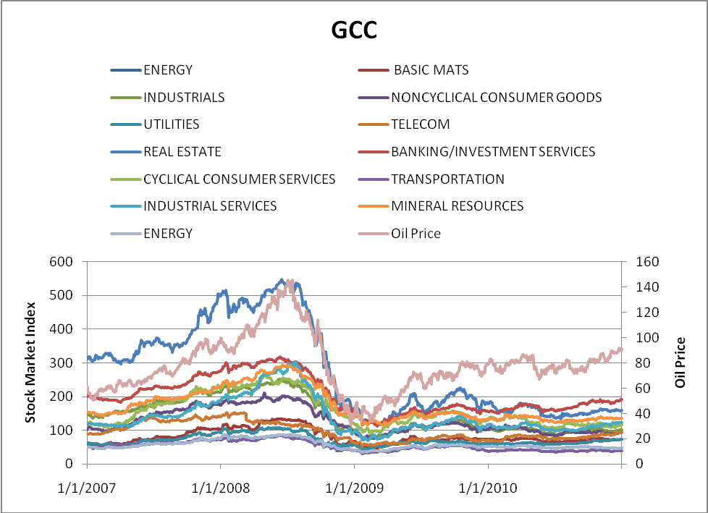 | 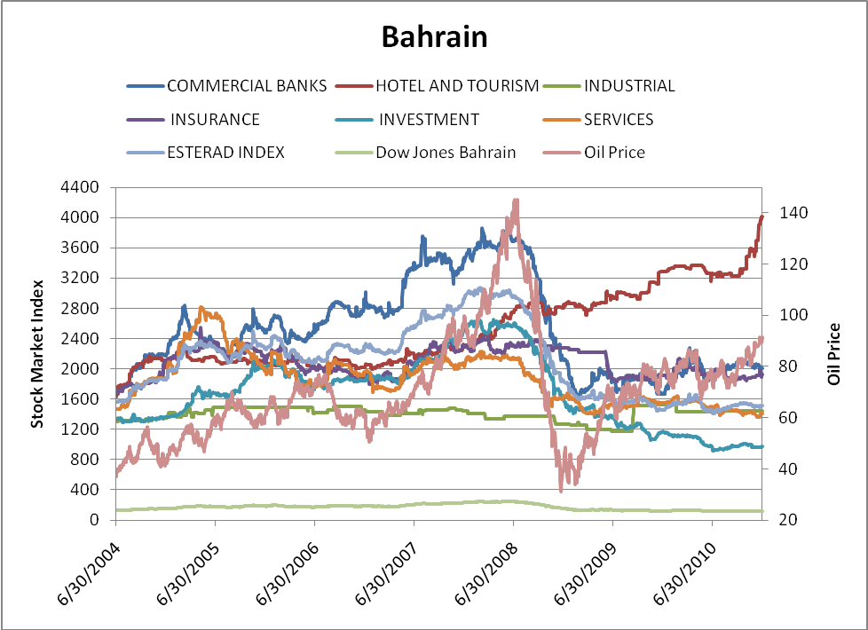
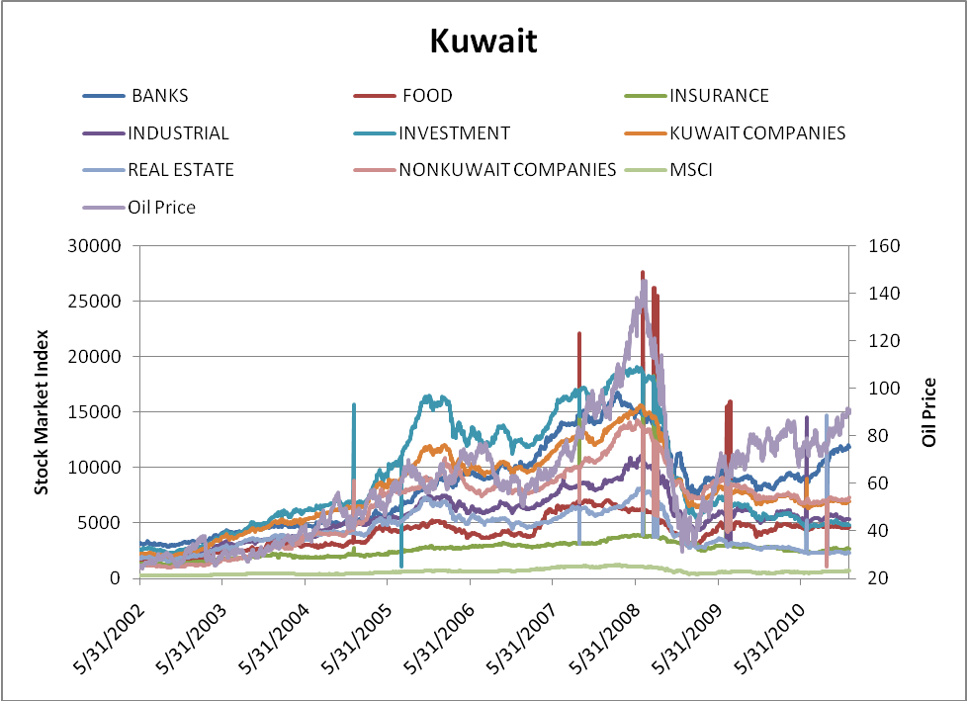 | 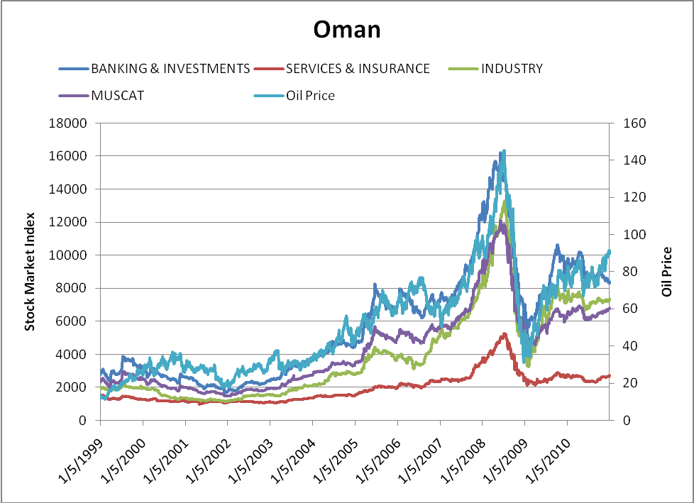
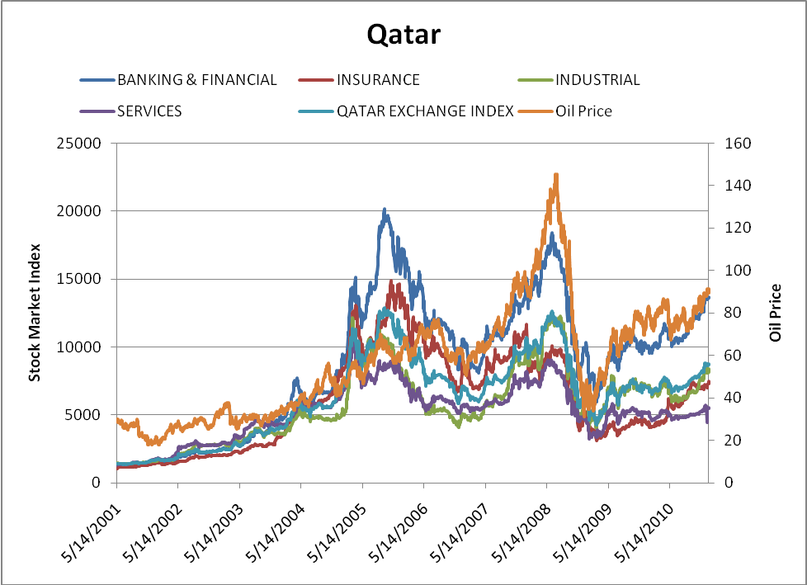 | 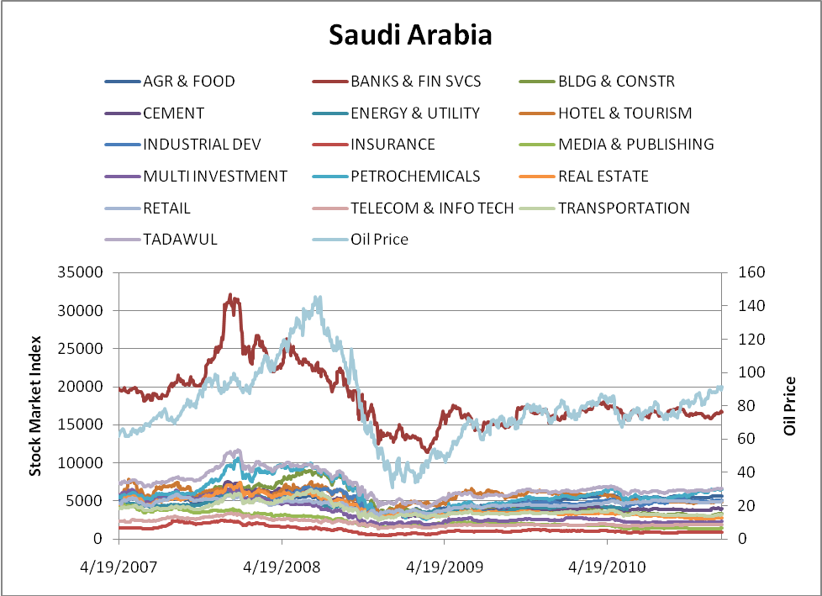
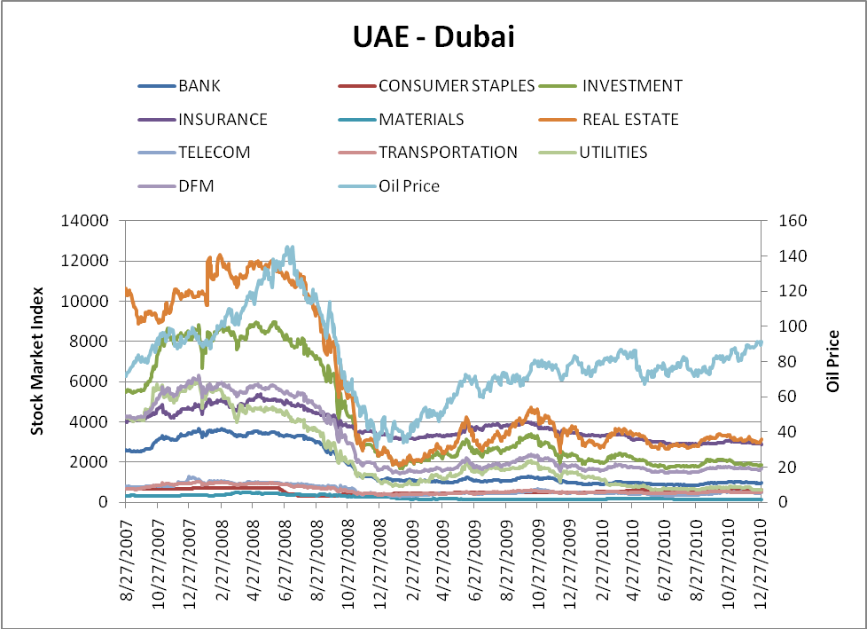 | 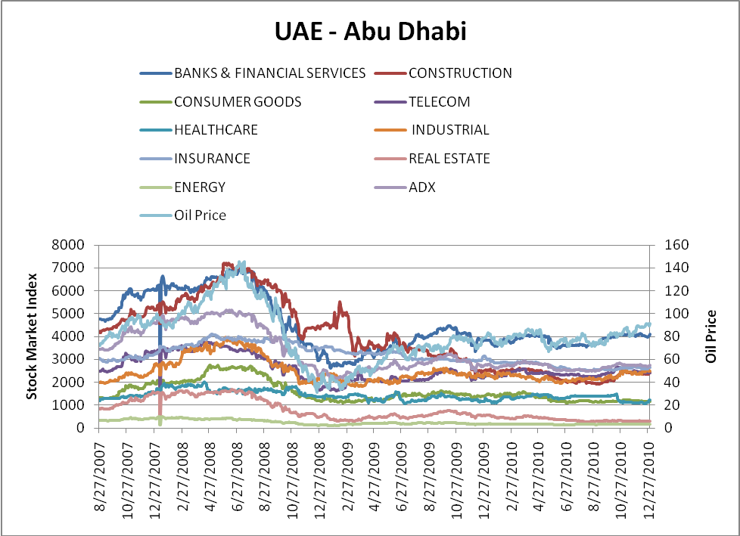

Table 2 Bahrain – Average Synchronicity Measures between Oil Price and Sectoral/National Stock Price Indexes (percent)
 | Sectoral Stock Price
 | Returns |  |  |  | 10-Day Volatility |  |  |  | 50-Day Volatility
 | Synchronicity with Oil Price Return/Volatility at time
National and Sectoral Indexes | t | t+1 | t-1 |  | t | t+1 | t-1 |  | t | t+1 | t-1
Overall Price Index | 50 | 50 | 47 |  | 59 | 59 | 59 |  | 69 | 69 | 69
Com. Banks | 49 | 49 | 48 |  | 55 | 55 | 56 |  | 60 | 60 | 59
Hotel & Tourism | 51 | 51 | 52 |  | 51 | 51 | 52 |  | 50 | 50 | 50
Industrial | 50 | 50 | 50 |  | 62 | 62 | 62 |  | 60 | 59 | 60
Insurance | 52 | 50 | 50 |  | 48 | 48 | 49 |  | 49 | 49 | 49
Investment | 49 | 51 | 48 |  | 61 | 61 | 61 |  | 63 | 63 | 63
Services | 50 | 50 | 48 |  | 56 | 57 | 57 |  | 57 | 57 | 57
ESTERAD | 49 | 50 | 46 |  | 58 | 58 | 59 |  | 66 | 66 | 65
Overall Synchronicity | 38 | 63 | 38 |  | 88 | 88 | 88 |  | 88 | 88 | 88
Average of Synchronicity Ratios above 50 | 51 | 50 | 51 |  | 58 | 58 | 58 |  | 61 | 61 | 61
Overall Synchronicity Without Main Index | 29 | 57 | 43 |  | 86 | 86 | 86 |  | 86 | 86 | 86
Average Synchronicity Without Main Index | 50 | 50 | 49 |  | 56 | 56 | 56 |  | 58 | 58 | 58
Multivariate Synchronicity Ratio | 41 | 42 | 40 |  | 52 | 52 | 53 |  | 58 | 59 | 58
Note: For the bivariate synchronicity measures, values indicate the fraction of time contemporaneous, lead, and lag oil prices and stock prices (sectoral and national) have coinciding cycles. The multivariate synchronicity measure is the average of matching and non-matching cycles at each point in time. Positive values indicate the dominance of synchronous cycles over asynchronous cycles in relation to the reference cycle. The multivariate synchronicity ratio is computed as the count of the positive averages over the total of all averages (positive and negative). All values are rounded off to the nearest whole number. As a result, slight discrepancy may exist in attempting to reconcile the values

Using a 50 percent benchmark, Overall Synchronicity is the ratio of synchronous cycles over 50 to the total number of synchronous cycles. For example, if all synchronicity ratios are above the benchmark, this measure is 100 percent. The Main Index is the overall market or national index. Since all number are rounded off, slight discrepancies exist in reconciling the individual synchronicity values and the overall synchronicity measure. For example, a value of 50.4 indicates synchronicity but it appears on the Table as 50. By focusing on the values of the Table, the overall synchronicity values may appear to be off, but they are correct as per the calculation based on the exact values.

Table 3 Kuwait – Average Synchronicity Measures between Oil Price and Sectoral/National Stock Price Indexes (percent)
 | Sectoral Stock Price
 | Returns |  |  |  | 10-Day Volatility |  |  |  | 50-Day Volatility
 | Synchronicity with Oil Price Return/Volatility at time
Sectors | t | t+1 | t-1 |  | t | t+1 | t-1 |  | t | t+1 | t-1
MSCI Kuwait | 49 | 49 | 47 |  | 63 | 63 | 63 |  | 71 | 71 | 70
Banks | 50 | 50 | 52 |  | 63 | 63 | 63 |  | 61 | 60 | 61
Food | 50 | 50 | 50 |  | 60 | 60 | 60 |  | 63 | 63 | 63
Insurance | 49 | 50 | 50 |  | 61 | 61 | 60 |  | 62 | 62 | 62
Industrial | 48 | 49 | 49 |  | 62 | 62 | 61 |  | 60 | 60 | 60
Investment | 48 | 48 | 47 |  | 64 | 64 | 64 |  | 59 | 59 | 59
Kuwait Companies | 47 | 49 | 48 |  | 61 | 61 | 61 |  | 56 | 56 | 56
Real Estate | 48 | 48 | 48 |  | 61 | 61 | 61 |  | 56 | 56 | 56
Non Kuwait Companies | 48 | 49 | 49 |  | 62 | 63 | 62 |  | 59 | 59 | 59
Overall Synchronicity | 11 | 11 | 22 |  | 100 | 100 | 100 |  | 100 | 100 | 100
Average of Synchronicity Ratios above 50 | 50 | 50 | 51 |  | 62 | 62 | 62 |  | 61 | 61 | 61
Overall Synchronicity Without Main Index | 13 | 13 | 25 |  | 100 | 100 | 100 |  | 100 | 100 | 100
Average Synchronicity Without Main Index | 49 | 49 | 49 |  | 62 | 62 | 61 |  | 59 | 59 | 59
Multivariate Synchronicity Ratio | 48 | 50 | 46 |  | 62 | 62 | 62 |  | 60 | 60 | 60
Note: For the bivariate synchronicity measures, values indicate the fraction of time contemporaneous, lead, and lag oil prices and stock prices (sectoral and national) have coinciding cycles. The multivariate synchronicity measure is the average of matching and non-matching cycles at each point in time. Positive values indicate the dominance of synchronous cycles over asynchronous cycles in relation to the reference cycle. The multivariate synchronicity ratio is computed as the count of the positive averages over the total of all averages (positive and negative). All values are rounded off to the nearest whole number.
Using a 50 percent benchmark, Overall Synchronicity is the ratio of synchronous cycles over 50 to the total number of synchronous cycles. For example, if all synchronicity ratios are above the benchmark, this measure is 100 percent. The Main Index is the overall market or national index. Since all number are rounded off, slight discrepancies exist in reconciling the individual synchronicity values and the overall synchronicity measure. For example, a value of 50.4 indicates synchronicity but it appears on the Table as 50. By focusing on the values of the Table, the overall synchronicity values may appear to be off, but they are correct as per the calculation based on the exact values.

Table 4 Oman – Average Synchronicity Measures between Oil Price and Sectoral/National Stock Price Indexes (percent)

 | Sectoral Stock Price
 | Returns |  |  |  | 10-Day Volatility |  |  |  | 50-Day Volatility
 | Synchronicity with Oil Price Return/Volatility at time
Sectors | t | t+1 | t-1 |  | t | t+1 | t-1 |  | t | t+1 | t-1
Muscat | 50 | 52 | 50 |  | 61 | 61 | 61 |  | 61 | 61 | 61
Banking & Investments | 50 | 49 | 49 |  | 63 | 62 | 63 |  | 62 | 62 | 62
Services & Insurance | 51 | 51 | 53 |  | 60 | 60 | 60 |  | 61 | 61 | 61
Industry | 51 | 54 | 53 |  | 62 | 62 | 62 |  | 57 | 57 | 57
Overall Synchronicity. | 50 | 75 | 25 |  | 100 | 100 | 100 |  | 100 | 100 | 100
Average of Synchronicity Ratios above 50 | 51 | 53 | 53 |  | 61 | 61 | 61 |  | 61 | 60 | 61
Overall Synchronicity Without Main Index | 67 | 67 | 33 |  | 100 | 100 | 100 |  | 100 | 100 | 100
Average Synchronicity Without Main Index | 51 | 52 | 51 |  | 62 | 61 | 62 |  | 60 | 60 | 60
Multivariate Synchronicity Ratio | 41 | 42 | 40 |  | 54 | 55 | 55 |  | 54 | 53 | 54
Note: For the bivariate synchronicity measures, values indicate the fraction of time contemporaneous, lead, and lag oil prices and stock prices (sectoral and national) have coinciding cycles. The multivariate synchronicity measure is the average of matching and non-matching cycles at each point in time. Positive values indicate the dominance of synchronous cycles over asynchronous cycles in relation to the reference cycle. The multivariate synchronicity ratio is computed as the count of the positive averages over the total of all averages (positive and negative). All values are rounded off to the nearest whole number.
Using a 50 percent benchmark, Overall Synchronicity is the ratio of synchronous cycles over 50 to the total number of synchronous cycles. For example, if all synchronicity ratios are above the benchmark, this measure is 100 percent. The Main Index is the overall market or national index. Since all number are rounded off, slight discrepancies exist in reconciling the individual synchronicity values and the overall synchronicity measure. For example, a value of 50.4 indicates synchronicity but it appears on the Table as 50. By focusing on the values of the Table, the overall synchronicity values may appear to be off, but they are correct as per the calculation based on the exact values.

Table 5 Qatar – Average Synchronicity Measures between Oil Price and Sectoral/National Stock Price Indexes (percent)
 | Sectoral Stock Price
 | Returns |  |  |  | 10-Day Volatility |  |  |  | 50-Day Volatility
 | Synchronicity with Oil Price Return/Volatility at time
Sectors | t | t+1 | t-1 |  | t | t+1 | t-1 |  | t | t+1 | t-1
Banking & Financial | 52 | 51 | 52 |  | 62 | 62 | 62 |  | 41 | 41 | 41
Insurance | 48 | 50 | 50 |  | 61 | 61 | 61 |  | 56 | 57 | 56
Industrial | 53 | 53 | 52 |  | 60 | 59 | 60 |  | 47 | 47 | 47
Services | 49 | 52 | 48 |  | 60 | 60 | 60 |  | 40 | 39 | 40
Qatar Exchange Index | 48 | 50 | 50 |  | 61 | 60 | 61 |  | 47 | 48 | 47
Overall Synchronicity | 60 | 80 | 60 |  | 100 | 100 | 100 |  | 20 | 20 | 20
Average of Synchronicity Ratios above 50 | 52 | 51 | 52 |  | 61 | 60 | 61 |  | 56 | 57 | 56
Overall Synchronicity Without Main Index | 50 | 75 | 50 |  | 100 | 100 | 100 |  | 25 | 25 | 25
Average Synchronicity Without Main Index | 50 | 51 | 50 |  | 61 | 61 | 61 |  | 46 | 46 | 46
Multivariate Synchronicity Ratio | 52 | 46 | 53 |  | 61 | 61 | 61 |  | 44 | 44 | 44
Note: For the bivariate synchronicity measures, values indicate the fraction of time contemporaneous, lead, and lag oil prices and stock prices (sectoral and national) have coinciding cycles. The multivariate synchronicity measure is the average of matching and non-matching cycles at each point in time. Positive values indicate the dominance of synchronous cycles over asynchronous cycles in relation to the reference cycle. The multivariate synchronicity ratio is computed as the count of the positive averages over the total of all averages (positive and negative). All values are rounded off to the nearest whole number.
Using a 50 percent benchmark, Overall Synchronicity is the ratio of synchronous cycles over 50 to the total number of synchronous cycles. For example, if all synchronicity ratios are above the benchmark, this measure is 100 percent. The Main Index is the overall market or national index. Since all number are rounded off, slight discrepancies exist in reconciling the individual synchronicity values and the overall synchronicity measure. For example, a value of 50.4 indicates synchronicity but it appears on the Table as 50. By focusing on the values of the Table, the overall synchronicity values may appear to be off, but they are correct as per the calculation based on the exact values.

Table 6 Saudi Arabia – Average Synchronicity Measures between Oil Price and Sectoral/National Stock Price Indexes (percent)
 | Sectoral Stock Price
 |  | Returns |  |  | 10-Day Volatility |  |  |  | 50-Day Volatility
 | Synchronicity with Oil Price Return/Volatility at time
Sectors | t | t+1 | t-1 |  | t | t+1 | t-1 |  | t | t+1 | t-1
Tadawul | 49 | 52 | 47 |  | 78 | 77 | 78 |  | 68 | 68 | 68
Agr & Food | 53 | 52 | 51 |  | 71 | 71 | 72 |  | 73 | 73 | 73
Banks & Fin Svcs | 47 | 49 | 47 |  | 70 | 70 | 71 |  | 57 | 57 | 57
Bldg & Constr | 45 | 51 | 48 |  | 74 | 74 | 73 |  | 69 | 69 | 68
Cement | 44 | 49 | 49 |  | 75 | 58 | 75 |  | 73 | 73 | 73
Energy & Utilities | 52 | 53 | 53 |  | 57 | 68 | 57 |  | 53 | 53 | 53
Hotel & Tourism | 48 | 51 | 48 |  | 68 | 73 | 68 |  | 72 | 72 | 70
Industrial Dev | 51 | 49 | 52 |  | 74 | 70 | 73 |  | 70 | 70 | 72
Insurance | 47 | 50 | 48 |  | 71 | 71 | 71 |  | 66 | 66 | 66
Media & Publishing | 47 | 48 | 50 |  | 71 | 71 | 72 |  | 68 | 68 | 68
Multi Investment | 47 | 50 | 49 |  | 71 | 78 | 71 |  | 72 | 72 | 72
Petrochemicals | 54 | 52 | 52 |  | 78 | 69 | 78 |  | 71 | 71 | 71
Real Estate Dev | 49 | 49 | 47 |  | 70 | 72 | 70 |  | 69 | 69 | 69
Retail | 54 | 50 | 50 |  | 72 | 72 | 72 |  | 68 | 67 | 68
Telecom & Info Tech | 47 | 48 | 50 |  | 72 | 71 | 71 |  | 67 | 66 | 67
Transportation | 48 | 49 | 46 |  | 72 | 72 | 71 |  | 67 | 68 | 67
Overall Synchronicity | 31 | 44 | 31 |  | 100 | 100 | 100 |  | 100 | 100 | 100
Average of Synchronicity Ratios above 50 | 53 | 52 | 52 |  | 71 | 71 | 71 |  | 68 | 68 | 68
Overall Synchronicity Without Main Index | 33 | 40 | 33 |  | 100 | 100 | 100 |  | 100 | 100 | 100
Average Synchronicity Without Main Index | 49 | 50 | 49 |  | 71 | 71 | 71 |  | 68 | 67 | 68
Multivariate Synchronicity Ratio | 41 | 45 | 42 |  | 76 | 76 | 76 |  | 69 | 69 | 69
Note: For the bivariate synchronicity measures, values indicate the fraction of time contemporaneous, lead, and lag oil prices and stock prices (sectoral and national) have coinciding cycles. The multivariate synchronicity measure is the average of matching and non-matching cycles at each point in time. Positive values indicate the dominance of synchronous cycles over asynchronous cycles in relation to the reference cycle. The multivariate synchronicity ratio is computed as the count of the positive averages over the total of all averages (positive and negative). All values are rounded off to the nearest whole number.
Using a 50 percent benchmark, Overall Synchronicity is the ratio of synchronous cycles over 50 to the total number of synchronous cycles. For example, if all synchronicity ratios are above the benchmark, this measure is 100 percent. The Main Index is the overall market or national index. Since all number are rounded off, slight discrepancies exist in reconciling the individual synchronicity values and the overall synchronicity measure. For example, a value of 50.4 indicates synchronicity but it appears on the Table as 50. By focusing on the values of the Table, the overall synchronicity values may appear to be off, but they are correct as per the calculation based on the exact values.

Table 7 UAE – Abu Dhabi – Average Synchronicity Measures between Oil Price and Sectoral/National Stock Price Indexes (percent)
 |  | Sectoral Stock Price
 |  | Returns |  |  |  | 10-Day Volatility |  |  |  | 50-Day Volatility
 |  | Synchronicity with Oil Price Return/Volatility at time
Sectors |  | t | t+1 | t-1 |  | t | t+1 | t-1 |  | t | t+1 | t-1
ADX |  | 46 | 48 | 46 |  | 71 | 72 | 71 |  | 54 | 54 | 54
Banks & Financial Services |  | 48 | 47 | 47 |  | 64 | 63 | 64 |  | 47 | 47 | 47
Construction |  | 49 | 51 | 49 |  | 65 | 64 | 65 |  | 53 | 53 | 54
Consumer |  | 51 | 51 | 51 |  | 60 | 59 | 59 |  | 27 | 27 | 26
Telecom |  | 50 | 51 | 50 |  | 60 | 60 | 60 |  | 39 | 39 | 39
Healthcare |  | 52 | 53 | 49 |  | 57 | 58 | 57 |  | 52 | 52 | 52
Industrial |  | 51 | 49 | 51 |  | 56 | 57 | 56 |  | 48 | 48 | 48
Insurance |  | 50 | 49 | 51 |  | 42 | 41 | 42 |  | 39 | 39 | 39
Real Estate |  | 47 | 50 | 50 |  | 66 | 66 | 66 |  | 39 | 39 | 39
Energy |  | 47 | 49 | 48 |  | 61 | 60 | 62 |  | 50 | 50 | 49
Overall Synchronicity |  | 40 | 50 | 30 |  | 90 | 90 | 90 |  | 30 | 30 | 30
Average of Synchronicity Ratios above 50 |  | 51 | 51 | 51 |  | 62 | 62 | 62 |  | 53 | 53 | 53
Overall Synchronicity Without Main Index |  | 44 | 56 | 33 |  | 89 | 89 | 89 |  | 22 | 22 | 22
Average Synchronicity Without Main Index |  | 49 | 50 | 50 |  | 59 | 59 | 59 |  | 44 | 44 | 44
Multivariate Synchronicity Ratio |  | 40 | 40 | 40 |  | 64 | 63 | 64 |  | 42 | 42 | 42
Note: For the bivariate synchronicity measures, values indicate the fraction of time contemporaneous, lead, and lag oil prices and stock prices (sectoral and national) have coinciding cycles. The multivariate synchronicity measure is the average of matching and non-matching cycles at each point in time. Positive values indicate the dominance of synchronous cycles over asynchronous cycles in relation to the reference cycle. The multivariate synchronicity ratio is computed as the count of the positive averages over the total of all averages (positive and negative). All values are rounded off to the nearest whole number.
Using a 50 percent benchmark, Overall Synchronicity is the ratio of synchronous cycles over 50 to the total number of synchronous cycles. For example, if all synchronicity ratios are above the benchmark, this measure is 100 percent. The Main Index is the overall market or national index. Since all number are rounded off, slight discrepancies exist in reconciling the individual synchronicity values and the overall synchronicity measure. For example, a value of 50.4 indicates synchronicity but it appears on the Table as 50. By focusing on the values of the Table, the overall synchronicity values may appear to be off, but they are correct as per the calculation based on the exact values.

Table 8 UAE – Dubai – Average Synchronicity Measures between Oil Price and Sectoral/National Stock Price Indexes (percent)
 | Sectoral Stock Price
 | Returns |  |  |  | 10-Day Volatility |  |  |  | 50-Day Volatility
 | Synchronicity with Oil Price Return/Volatility at time
Sectors | t | t+1 | t-1 |  | t | t+1 | t-1 |  | t | t+1 | t-1
Bank | 45 | 48 | 49 |  | 63 | 63 | 63 |  | 56 | 56 | 56
Consumer Staples | 52 | 51 | 51 |  | 64 | 63 | 65 |  | 64 | 64 | 64
Financial Investment | 46 | 49 | 50 |  | 69 | 69 | 69 |  | 64 | 54 | 63
Insurance | 46 | 50 | 52 |  | 52 | 53 | 52 |  | 35 | 35 | 35
Materials | 49 | 52 | 52 |  | 62 | 63 | 62 |  | 53 | 64 | 53
Real Estate | 43 | 47 | 52 |  | 68 | 68 | 68 |  | 63 | 63 | 63
Telecomm | 50 | 49 | 52 |  | 61 | 61 | 61 |  | 59 | 59 | 59
Transport | 46 | 47 | 52 |  | 68 | 67 | 68 |  | 64 | 64 | 64
Utilities | 48 | 49 | 50 |  | 65 | 66 | 65 |  | 58 | 58 | 58
DFM | 45 | 48 | 51 |  | 67 | 67 | 67 |  | 63 | 63 | 63
Overall Synchronicity | 20 | 20 | 80 |  | 100 | 100 | 100 |  | 90 | 90 | 90
Average of Synchronicity Ratios above 50 | 51 | 52 | 51 |  | 64 | 64 | 64 |  | 61 | 61 | 60
Overall Synchronicity Without Main Index | 22 | 22 | 78 |  | 100 | 100 | 100 |  | 89 | 89 | 89
Average Synchronicity Without Main Index | 47 | 49 | 51 |  | 64 | 64 | 64 |  | 57 | 57 | 57
Multivariate Synchronicity Ratio | 42 | 45 | 47 |  | 67 | 67 | 67 |  | 61 | 61 | 61
Note: For the bivariate synchronicity measures, values indicate the fraction of time contemporaneous, lead, and lag oil prices and stock prices (sectoral and national) have coinciding cycles. The multivariate synchronicity measure is the average of matching and non-matching cycles at each point in time. Positive values indicate the dominance of synchronous cycles over asynchronous cycles in relation to the reference cycle. The multivariate synchronicity ratio is computed as the count of the positive averages over the total of all averages (positive and negative). All values are rounded off to the nearest whole number.
Using a 50 percent benchmark, Overall Synchronicity is the ratio of synchronous cycles over 50 to the total number of synchronous cycles. For example, if all synchronicity ratios are above the benchmark, this measure is 100 percent. The Main Index is the overall market or national index. Since all number are rounded off, slight discrepancies exist in reconciling the individual synchronicity values and the overall synchronicity measure. For example, a value of 50.4 indicates synchronicity but it appears on the Table as 50. By focusing on the values of the Table, the overall synchronicity values may appear to be off, but they are correct as per the calculation based on the exact values.

Table 9 Overall GCC – Average Synchronicity Measures between Oil Price and Sectoral/National Stock Price Indexes (percent)
 | Sectoral Stock Price
 | Returns |  |  |  | 10-Day Volatility |  |  |  | 50-Day Volatility
 | Synchronicity with Oil Price Return/Volatility at time
Sectors | t | t+1 | t-1 |  | t | t+1 | t-1 |  | t | t+1 | t-1
Energy | 51 | 48 | 48 |  | 70 | 71 | 69 |  | 59 | 59 | 59
Basic Mats | 51 | 49 | 47 |  | 72 | 72 | 71 |  | 75 | 75 | 75
Non-Cyclical Consumer Goods | 53 | 51 | 50 |  | 67 | 67 | 66 |  | 73 | 73 | 73
Utilities | 53 | 50 | 53 |  | 74 | 74 | 73 |  | 73 | 73 | 73
Telecommunication | 51 | 50 | 50 |  | 69 | 69 | 69 |  | 72 | 72 | 71
Real Estate | 46 | 48 | 46 |  | 70 | 70 | 69 |  | 66 | 67 | 66
Banking/Inv Services | 49 | 48 | 47 |  | 76 | 76 | 75 |  | 72 | 72 | 71
Cyclical Consumer Goods | 51 | 50 | 51 |  | 64 | 65 | 64 |  | 69 | 69 | 69
Transportation | 49 | 49 | 48 |  | 69 | 69 | 69 |  | 71 | 71 | 71
Industrial Services | 51 | 48 | 49 |  | 69 | 70 | 69 |  | 68 | 69 | 68
Mineral Resources | 50 | 49 | 47 |  | 71 | 71 | 71 |  | 67 | 67 | 67
Overall Synchronicity | 73 | 18 | 18 |  | 100 | 100 | 100 |  | 100 | 100 | 100
Average of Synchronicity Ratios above 50 | 51 | 51 | 52 |  | 70 | 70 | 70 |  | 70 | 70 | 69
Multivariate Synchronicity | 50 | 48 | 48 |  | 78 | 79 | 77 |  | 73 | 74 | 73
Note: For the bivariate synchronicity measures, values indicate the fraction of time contemporaneous, lead, and lag oil prices and stock prices (sectoral and national) have coinciding cycles. The multivariate synchronicity measure is the average of matching and non-matching cycles at each point in time. Positive values indicate the dominance of synchronous cycles over asynchronous cycles in relation to the reference cycle. The multivariate synchronicity ratio is computed as the count of the positive averages over the total of all averages (positive and negative). All values are rounded off to the nearest whole number.
Using a 50 percent benchmark, Overall Synchronicity is the ratio of synchronous cycles over 50 to the total number of synchronous cycles. For example, if all synchronicity ratios are above the benchmark, this measure is 100 percent. The Main Index is the overall market or national index. Since all number are rounded off, slight discrepancies exist in reconciling the individual synchronicity values and the overall synchronicity measure. For example, a value of 50.4 indicates synchronicity but it appears on the Table as 50. By focusing on the values of the Table, the overall synchronicity values may appear to be off, but they are correct as per the calculation based on the exact values.

Table 10 Common Factors Based on Returns
Bahrain | Commercial Banks | Hotel & Tourism | Industry | Insurance | Investment | Services
a_{i} |  |  |  |  | 0.07 (2.55)
b_{i} | 0.005 (7.29) | 0.001 (3.41) |  | 0.001 (2.91) | 0.002 (6.01) | 0.003 (6.71)
d | 0.44 (5.81)
Oman | Banking & Investments | Services & Insurance | Industry
a_{i} | 0.11 (2.70) | 0.10 (1.95) | 0.13 (3.32)
b_{i} | 0.01 (20.72) | 0.01 (15.56) | 0.01 (19.98)
d | 0.25 (3.44)
Qatar | Banking & Financial | Insurance | Industrial | Services |  |  |  | `
a_{i} | 0.26 (7.47) | 0.07 (1.76) | 0.15 (3.57)
b_{i} | 0.01 (26.74) | 0.01 (20.12) | 0.02 (27.67) | 0.01(25.08)
d | 0.25 (5.30)
UAE - Abu Dhabi | Banks & Financial Services | Construction | Consumer goods | Telecommunication | Healthcare | Industry | Insurance | Real Estate | Energy
a_{i} |  |  | -0.17 (-4.46)
b_{i} | 0.04 (3.37) | 0.01 (5.37) | 0.03 (3.39) | 0.03 (3.27) | 0.01 (3.29) | 0.01 (4.76) |  | 0.05 (3.66) | 0.06 (3.07)
d | 0.05 (1.94)
UAE-Dubai | Bank | Consumer Staples | Financial Investment | Insurance | Materials | Real Estate | Telecommunication | Transportation | Utilities
a_{i} | 0.10 (2.00) | 0.34 (4.42) |  |  |  |  | 0.10 (1.88)
b_{i} | 0.01 (16.88) |  | 0.03 (20.38) | 0.01 (14.83) |  | 0.03 (17.05) | 0.02 (14.52) | 0.02 (14.68) | 0.03 (19.39)
d | -0.01*(-0.14)
Model estimated: Y_{i,t} = a_{i}Y_{i,t-1} + b_{i}Z_{t} + e_{i,t}, Z_{t} = dZ_{t-1} + v_{t} ; t-statistics in brackets.

Table 10 Common Factors Based on Returns (Cont’d)
Saudi Arabia | Agriculture & Food | Banks & Financial Services | Building & Construction | Cement | Energy & Utility | Hotel & Tourism | Industrial Development | Insurance | Media & Publishing | Multi-purpose Investment | Petrochemicals | Real Estate Development | Retail | Telecommunications & Information Technology | Transportation
a_{i} |  |  | 0.21 (4.38) |  | -0.26 (-4.82)
b_{i} | 0.02 (16.26) | 0.01 (11.71) | 0.02 (18.49) | 0.01 (8.78) | 0.01 (9.69) | 0.02 (11.90) | 0.02 (15.96) | 0.02 (15.70) | 0.02 (13.08) | 0.02 (14.53) | 0.02 (12.03) | 0.02 (14.73) | 0.02 (14.00) | 0.01 (13.90) | 0.02 (16.56)
d | 0.06 (1.00)
GCC
 | Energy | Basic Materials | Industry | Non-Cyclical Consumer Goods & Services | Utilities | Telecommunication Services | Real Estate | Banking &Investment Services | Cyclical Consumer Goods & Services | Transportation | Industrial Services | Mineral Resources
a_{i} |  |  |  | -0.1*(-2.84) |  |  |  |  | -0.08 (-2.39)
b_{i} | 0.01 (13.10) | 0.02 (12.42) | 0.01 (16.07) | 0.01 (10.19) | 0.01 (10.29) | 0.01 (10.28) | 0.02 (12.97) | 0.01 (13.74) | 0.01 (8.88) | 0.02 (15.47) | 0.01 (11.27) | 0.01 (10.74)
d | 0.14 (2.32)
Nationals
 | DJ - Bahrain | Bahrain | Kuwait | Oman | Qatar | Saudi | UAE - Abu Dhabi | UAE - Dubai
a_{i} |  |  |  |  |  | -0.10 (-1.79) | -0.33 (-5.31)
b_{i} | 0.003 (6.40) | 0.002 (7.37) | 0.006 (5.14) | 0.01 (10.26) | 0.01 (11.20) | 0.01 (6.25) | 0.01 (12.92) | 0.01 (12.16)
d | 0.36 (3.63)
Model estimated: Y_{i,t} = a_{i}Y_{i,t-1} + b_{i}Z_{t} + e_{i,t}, Z_{t} = dZ_{t-1} + v_{t} ; t-statistics in brackets.

Table 11 Common Factor Results based on 10-day Volatility
Bahrain
 | Commercial Banks | Hotel & Tourism | Industry | Insurance | Investment | Services
b | 0.07 (25.56) | 0.03 (25.01) | 0.002 (15.89) | 0.005 (24.31) | 0.005 (25.57) | 0.006 (25.57)
d1 | 1.68 (98.27)
d2 | -0.69  (-40.03)
Kuwait
 | Banks | Food | Insurance | Industry | Investment | Kuwait Companies | Real Estate | Non Kuwait Companies
b | 0.07 (6.57) | 0.44 (7.48) | 0.40 (7.63) | 0.15 (7.06) | 0.11 (7.94) | 0.02 (6.38) | 0.20 (7.63) | 0.25 (8.26)
d1 | 1.31 (13.34)
d2 | -0.35 (-3.34)
Oman
 | Banking & Investments | Services & Insurance | Industry
b | 0.02 (14.89) | 0.01 (14.70) | 0.018 (14.74)
d1 | 1.52 (32.22)
d2 | -0.53 (-11.16)
Qatar
 | Banking & Financial | Insurance | Industrial | Services |  |  |  | `
b | 0.013 (25.98) | 0.014 (26.20) | 0.014 (25.92) | 0.012 (25.82)
d1 | 1.71 (96.29)
d2 | -0.72 (-40.08)
UAE - Abu Dhabi
 | Banks & Financial Services | Construction | Consumer goods | Telecommunication | Healthcare | Industry | Insurance | Real Estate | Energy
b | 0.14 (2.45) | 0.06 (2.51) | 0.12 (2.49) | 0.13 (2.45) | 0.08 (2.51) | 0.07 (2.50) | 0.02 (2.46) | 0.22 (2.47) | 0.26 (2.42)
d1 | 1.20 (5.98)
d2 | -0.24 (-1.24)
UAE-Dubai
 | Bank | Consumer Staples | Financial Investment | Insurance | Materials | Real Estate | Telecommunication | Transportation | Utilities
b | 0.012 (14.48) | 0.02 (14.75) |  | 0.01 (14.00) | 0.013 (14.46) | 0.03 (14.79) | 0.02 (14.04) | 0.02 (14.37) | 0.03 (15.00)
d1 | 1.74 (60.51)
d2 | -0.75 (-25.74)

Table 11 Common Factor Results based on 10-day Volatility (Cont’d)
Saudi Arabia
 | Agriculture & Food | Banks & Financial Services | Building & Construction | Cement | Energy & Utility | Hotel & Tourism | Industrial Development | Insurance | Media & Publishing | Multi-purpose Investment | Petrochemicals | Real Estate Development | Retail | Telecommunications & Information Technology | Transportation
b | 0.02 (8.18) | 0.02 (8.19) | 0.03 (8.22) | 0.02 (8.09) | 0.02 (8.22) | 0.03 (8.22) | 0.03 (8.17) | 0.03 (8.28) | 0.03 (8.21) | 0.03 (8.16) | 0.03 (7.96) | 0.02 (8.15) | 0.02 (8.17) | 0.02 (8.18) | 0.03 (8.22)
d1 | 1.49 (24.96)
d2 | -0.49 (-8.23)
GCC
 | Energy | Basic Materials | Industry | Non-Cyclical Consumer Goods & Services | Utilities | Telecommunication Services | Real Estate | Banking &Investment Services | Cyclical Consumer Goods & Services | Transportation | Industrial Services | Mineral Resources
b | 0.01 (8.28) | 0.02 (8.36) | 0.01 (8.30) | 0.01 (8.49) | 0.02 (8.31) | 0.01 (8.39) | 0.02 (8.25) | 0.01 (8.29) | 0.02 (8.52) | 0.02 (8.34) | 0.02 (8.31) | 0.01 (8.29)
d1 | 1.65 (34.61)
d2 | -0.65 (-13.65)
Nationals
 | DJ - Bahrain | Bahrain | Kuwait | Oman | Qatar | Saudi | UAE - Abu Dhabi | UAE - Dubai
b | 0.004 (16.48) | 0.004 (17.07) | 0.01 (15.94) | 0.008 (14.06) | 0.011 (15.35) | 0.01 (14.90) | 0.008 (15.00) | 0.012 (15.10)
d1 | 1.75 (70.22)
d2 | -0.75 (-30.53)
Results are based on the estimation of Model 2: Y_{i,t} = b_{i}Z_{t} + e_{i,t}, Z_{t} = d₁Z_{t-1} + d₂Z_{t-2} + v_{t}.

Table 12 Common Factor Results based on 50-day volatility
Bahrain
 | Commercial Banks | Hotel & Tourism | Industry | Insurance | Investment | Services
b | 0.006 (25.86) | 0.004 (23.45) | 0.004 (25.20) | 0.005 (23.95) | 0.004 (22.48) | 0.006 (24.88)
d1 | 1.92 (1.2e+04)
d2 | -0.92 (-5621.71)
Kuwait
 | Banks | Food | Insurance | Industry | Investment | Kuwait Companies | Real Estate | Non Kuwait Companies
b | -0.52 (-4.32) | -0.51 (-4.74) | -0.57 (-4.44) | -0.26 (-4.42) | -0.40 (-5.14) | -0.13 (-4.34) | -0.83 (-4.57) | -0.71 (-4.27)
d1 | 1.76 (14.14)
d2 | -0.77 (-6.12)
Oman
 | Banking & Investments | Services & Insurance | Industry
b | 0.01 (10.36) | 0.02 (12.63) | 0.10 (11.95)
d1 | 1.88 (54.94)
d2 | -0.88 (-25.81)
Qatar
 | Banking & Financial | Insurance | Industrial | Services |  |  |  | `
b | 0.03 (17.53) | 0.01 (11.30) | 0.01 (13.13) | 0.02 (14.76)
d1 | 1.88 (72.30)
d2 | -0.88 (-33.92)
UAE - Abu Dhabi
 | Banks & Financial Services | Construction | Consumer goods | Telecommunication | Healthcare | Industry | Insurance | Real Estate | Energy
b | 0.21 (5.91) | 0.06 (5.89) | 0.15 (5.91) | 0.2 (5.91) | 0.07 (5.88) | 0.05 (5.89) | 0.01 (5.60) | 0.31 (5.91) | 0.42 (5.90)
d1 | 1.90 (33.83)
d2 | -0.89 (-15.90)
UAE-Dubai
 | Bank | Financial Investment | Insurance | Materials | Real Estate | Telecommunication | Transportation | Utilities
b | 0.02 (16.52) | 0.05 (16.92) | 0.02 (16.13) | 0.03 (16.75) | 0.05 (17.32) | 0.04 (15.29) | 0.04 (16.57) | 0.05 (17.12)
d1 | 1.87 (134.40)
d2 | -0.87 (-62.60)

Table 12 Common Factor Results based on 50-day volatility (Cont’d)
Saudi Arabia
 | Agriculture & Food | Banks & Financial Services | Building & Construction | Cement | Energy & Utility | Hotel & Tourism | Industrial Development | Insurance | Media & Publishing | Multi-purpose Investment | Petrochemicals | Real Estate Development | Retail | Telecommunications & Information Technology | Transportation
b | 0.03 (15.55) | 0.03 (15.64) | 0.03 (15.90) | 0.03 (15.90) | 0.03 (15.88) | 0.04 (14.82) | 0.04 (15.62) | 0.03 (15.66) | 0.04 (15.97) | 0.04 (15.37) | 0.05 (13.30) | 0.03 (15.65) | 0.03 (15.67) | 0.02 (15.67) | 0.03 (15.89)
d1 | 1.88 (94.21)
d2 | -0.88 (-43.84)
GCC
 | Energy | Basic Materials | Industry | Non-Cyclical Consumer Goods & Services | Utilities | Telecommunication Services | Real Estate | Banking &Investment Services | Cyclical Consumer Goods & Services | Transportation | Industrial Services | Mineral Resources
b | 0.02 (18.73) | 0.03 (18.29) | 0.02 (18.09) | 0.02 (19.56) | 0.03 (18.68) | 0.02 (19.36) | 0.03 (18.69) | 0.02 (18.62) | 0.02 (20.36) | 0.03 (18.17) | 0.03 (19.36) | 0.02 (18.46)
d1 | 1.88 (122.07)
d2 | -0.88 (-56.93)
Nationals
 | DJ - Bahrain | Bahrain | Kuwait | Oman | Qatar | Saudi | UAE - Abu Dhabi | UAE - Dubai
b | 0.01 (15.82) | 0.007 (16.50) | 0.02 (15.97) | 0.02 (14.28) | 0.02 (13.87) | 0.02 (14.56) | 0.02 (13.89) | 0.02 (13.65)
d1 | 1.88 (228.68)
d2 | -0.88 (-107.39)
Note: All models but Kuwait, Oman, and Qatar were estimated using Model 2: Y_{i,t} = b_{i}Z_{t} + e_{i,t}, Z_{t} = d₁Z_{t-1} + d₂Z_{t-2} + v_{t}. This type of model did not work for these three countries. We therefore report the models that were possible to be estimated. Kuwait: Model 3: Y_{i,t} = a_{i}Y_{i,t-1} + b_{i}Z_{t} + e_{i,t}, Z_{t} = d₁Z_{t-1} + d₂Z_{t-2} + v_{t}, Oman: Model 4: Y_{i,t} = α + a_{i}Y_{i,t-1} + b_{i}Z_{t} + e_{i,t}, Z_{t} = d₁Z_{t-1} + d₂Z_{t-2} + v_{t},, Qatar: Model 3: Y_{i,t} = a_{i}Y_{i,t-1} + b_{i}Z_{t} + e_{i,t}, Z_{t} = d₁Z_{t-1} + d₂Z_{t-2} + v_{t},

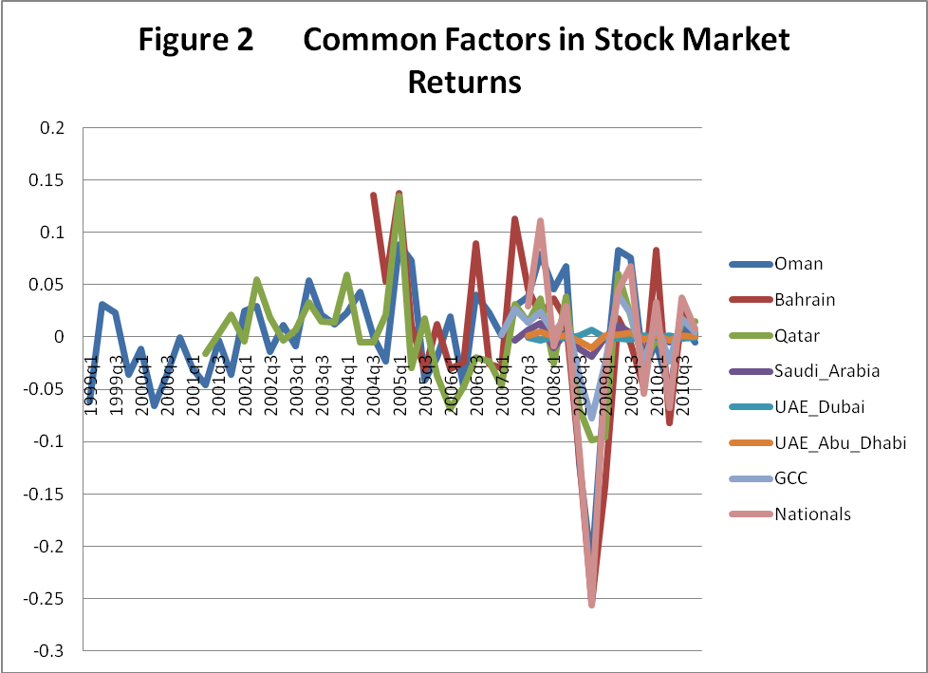
Table 13 Regression results of equity-return-based common factors on the daily returns of oil prices
 | Lags | 0 | 1 | 2 | 3 | 4 | 5 | 6 | 7 | 8 | R-square | RMSE
Bahrain
 | Model 1 |  |  | -0.01 | -0.017 |  | -0.008 | -0.009 |  |  | 0.03 | 0.36
 |  |  |  | -2.32 | -4.13 |  | -2.1 | -2.23
 | Model 2 |  |  | 0.007 | 0.015 | 0.08 | 0.01 | 0.01 |  |  | 0.03 | 0.32
 |  |  |  | 2.19 | 4.21 | 2.22 | 2.74 | 2.68
 | Model 3 |  |  | 0.008 | 0.015 | 0.008 | 0.1 | 0.01 |  |  | 0.04 | 0.31
 |  |  |  | 2.28 | 4.36 | 2.42 | 2.86 | 2.87
 | Model 4 |  |  | 0.008 | 0.015 | 0.008 | 0.1 | 0.01 |  |  | 0.04 | 0.31
 |  |  |  | 2.26 | 4.34 | 2.4 | 2.84 | 2.85
Kuwait
Oman
 | Model 1 |  | 0.01 | 0.012 | 0.008 | 0.007 | 0.01 | 0.006 |  |  | 0.03 | 0.28
 |  |  | 2.6 | 3.17 | 2.28 | 2.19 | 2.79 | 1.71
 | Model 2 |  | 0.01 | 0.012 | 0.008 | 0.007 | 0.01 | 0.006 |  |  | 0.03 | 0.28
 |  |  | 2.6 | 3.18 | 2.28 | 2.19 | 2.79 | 1.73
 | Model 3 |  | 0.008 | 0.01 | 0.007 | 0.006 | 0.008 | 0.004 |  |  | 0.03 | 0.24
 |  |  | 2.59 | 3.21 | 2.4 | 2.15 | 2.84 | 1.66
 | Model 4 |  | 0.008 | 0.01 | 0.007 | 0.006 | 0.008 | 0.004 |  |  | 0.03 | 0.24
 |  |  | 2.56 | 3.17 | 2.36 | 2.12 | 2.81 | 1.62
Qatar
 | Model 1 |  | 0.007 | 0.01 | 0.006 | 0.004 | 0.006 |  |  | 0.006 | 0.03 | 0.25
 |  |  | 2.67 | 3.49 | 2.19 | 1.74 | 2.35 |  |  | 2.11
 | Model 2 |  | 0.007 | 0.01 | 0.006 | 0.004 | 0.006 |  |  | 0.006 | 0.03 | 0.25
 |  |  | 2.58 | 3.42 | 2.19 | 1.77 | 2.25 |  |  | 2.07
 | Model 3 |  | 0.007 | 0.01 | 0.006 | 0.004 | 0.006 |  |  | 0.005 | 0.03 | 0.24
 |  |  | 2.62 | 3.43 | 2.16 | 1.74 | 2.24 |  |  | 2.12
 | Model 4 |  | 0.007 | 0.01 | 0.006 | 0.004 | 0.006 |  |  | 0.005 | 0.03 | 0.24
 |  |  | 2.58 | 3.38 | 2.13 | 1.7 | 2.2 |  |  | 2.08

Table 13 Regression results of equity-return-based common factors on the daily returns oil prices (Cont’d)
 | Lags | 0 | 1 | 2 | 3 | 4 | 5 | 6 | 7 | 8 | R-square | RMSE
Saudi Arabia
 | Model 1 |  |  |  |  |  |  |  | 0.003 | 0.002 | 0.04 | 0.06
 |  |  |  |  |  |  |  |  | 2.42 | 2.38
 | Model 2 |  |  |  |  |  |  |  | 0.003 | 0.002 | 0.04 | 0.06
 |  |  |  |  |  |  |  |  | 2.41 | 2.4
 | Model 3 |  |  |  |  |  |  |  | 0.003 | 0.002 | 0.04 | 0.06
 |  |  |  |  |  |  |  |  | 2.42 | 2.38
 | Model 4 |  |  |  |  |  |  |  | 0.003 | 0.002 | 0.04 | 0.06
 |  |  |  |  |  |  |  |  | 2.42 | 2.38
UAE - Dubai
 | Model 1 |  | 0.003 | 0.002 |  |  | 0.002 | 0.002 |  |  | 0.05 | 0.07
 |  |  | 3.1 | 2.13 |  |  | 2.2 | 2.26
 | Model 2 |  | -0.0005 | -0.0004 |  |  | -0.0004 | -0.0003 |  |  | 0.04 | 0.01
 |  |  | -2.86 | -2.03 |  |  | -2.47 | -2.07
 | Model 3 |  | -0.0005 | -0.0004 |  |  | -0.0004 | -0.0003 |  |  | 0.04 | 0.01
 |  |  | -2.85 | -2.01 |  |  | -2.42 | -2.04
 | Model 4 |  | -0.0005 | -0.0004 |  |  | -0.0004 | -0.0003 |  |  | 0.04 | 0.01
 |  |  | -2.88 | -2.03 |  |  | -2.44 | -2.06
UAE - Abu Dhabi
 | Model 1 |  |  | -0.004 |  | -0.003 |  |  |  |  | 0.01 | 0.22
 |  |  |  | -2.2 |  | -1.85
 | Model 2 |  | 0.001 | 0.001 |  | 0.001 |  |  |  |  | 0.01 | 0.05
 |  |  | 2.53 | 2.26 |  | 1.88
 | Model 3 |  | 0.001 | 0.001 |  | 0.001 |  |  |  |  | 0.01 | 0.05
 |  |  | 2.52 | 2.25 |  | 1.86
 | Model 4 |  | 0.001 | 0.001 |  | 0.001 |  |  |  |  | 0.01 | 0.05
 |  |  | 2.53 | 2.26 |  | 1.87
The common factors used as dependent variables were extracted from the following models:
Model 1: Y_{i,t} = b_{i}Z_{t} + e_{i,t}, Z_{t} = dZ_{t-1} + v_{t}; Model 2: Y_{i,t} = α + b_{i}Z_{t} + e_{i,t}, Z_{t} = dZ_{t-1} + v_{t};
Model 3: Y_{i,t} = a_{i}Y_{i,t-1} + b_{i}Z_{t} + e_{i,t}, Z_{t} = dZ_{t-1} + v_{t}; Model 4: Y_{i,t} = α + a_{i}Y_{i,t-1} + b_{i}Z_{t} + e_{i,t}, Z_{t} = dZ_{t-1} + v_{t}. Only coefficients
That are statistically significant are reported, t-statistics are in italics.

Table 13 Regression results of equity-return-based common factors on the daily returns of oil prices (Cont’d)
 | Lags | 0 | 1 | 2 | 3 | 4 | 5 | 6 | 7 | 8 | R-square | RMSE
GCC - Wide Sectors
 | Model 1 |  | 0.004 | 0.006 | 0.005 | 0.006 | 0.004 |  |  | 0.004 | 0.07 | 0.13
 |  |  | 1.82 | 3.18 | 2.27 | 2.97 | 1.91 |  |  | 1.91
 | Model 2 |  | 0.004 | 0.006 | 0.005 | 0.006 | 0.004 |  |  | 0.004 | 0.07 | 0.13
 |  |  | 1.83 | 3.19 | 2.27 | 2.98 | 1.92 |  |  | 1.91
 | Model 3 |  | 0.006 | 0.01 | 0.007 | 0.09 | 0.006 |  |  | 0.005 | 0.07 | 0.2
 |  |  | 1.73 | 3.43 | 2.44 | 2.88 | 2.09 |  |  | 1.79
 | Model 4 |  | 0.006 | 0.01 | 0.007 | 0.09 | 0.006 |  |  | 0.005 | 0.06 | 0.2
 |  |  | 1.73 | 3.42 | 2.43 | 2.87 | 2.08 |  |  | 1.78
GCC - National Indexes
 | Model 1 |  | 0.02 | 0.022 | 0.124 | 0.011 | 0.014 | 0.011 |  |  | 0.11 | 0.33
 |  |  | 3.54 | 4.18 | 2.41 | 2.44 | 2.95 | 2.45
 | Model 2 |  | 0.018 | 0.022 | 0.012 | 0.011 | 0.014 | 0.011 |  |  | 0.11 | 0.32
 |  |  | 3.57 | 4.21 | 2.43 | 2.45 | 2.97 | 2.46
 | Model 3 |  | 0.02 | 0.023 | 0.012 | 0.011 | 0.014 | 0.012 |  |  | 0.1 | 0.34
 |  |  | 3.68 | 4.2 | 2.31 | 2.31 | 2.81 | 2.44
 | Model 4 |  | 0.02 | 0.023 | 0.012 | 0.011 | 0.014 | 0.012 |  |  | 0.11 | 0.34
 |  |  | 3.7 | 4.24 | 2.33 | 2.32 | 2.84 | 2.46
The common factors used as dependent variables were extracted from the following models:
Model 1: Y_{i,t} = b_{i}Z_{t} + e_{i,t}, Z_{t} = dZ_{t-1} + v_{t}; Model 2: Y_{i,t} = α + b_{i}Z_{t} + e_{i,t}, Z_{t} = dZ_{t-1} + v_{t};
Model 3: Y_{i,t} = a_{i}Y_{i,t-1} + b_{i}Z_{t} + e_{i,t}, Z_{t} = dZ_{t-1} + v_{t}; Model 4: Y_{i,t} = α + a_{i}Y_{i,t-1} + b_{i}Z_{t} + e_{i,t}, Z_{t} = dZ_{t-1} + v_{t}. Only coefficients
That are statistically significant are reported, t-statistics are in italics.

Table 14 Regression results of equity- return-based common factors on the 10-day historical volatility of oil prices
 | Lags | 0 | 8 | R-square | RMSE
Bahrain | Model 1 | 0.24 | 0.24 | 0.75 | 12.11
 |  | 2.05 | 2.07
Kuwait | Model 1 | 0.03 |  | 0.07 | 3.93
 |  | 1.66
Oman | Model 1 | 0.1 | 0.1 | 0.62 | 6.27
 |  | 3.3 | 3.13
 | Model 3 | -0.08 | -0.1 | 0.69 | 5.16
 |  | -3.29 | -3.59
Qatar | Model 1 | 0.21 | 0.21 | 0.70 | 10.92
 |  | 2.99 | 3.01
 | Model 3 | 0.11 | 0.12 | 0.70 | 5.63
 |  | 3.09 | 3.16
Saudi Arabia | Model 1 | 0.13 |  | 0.71 | 6.6
 |  | 2.2
 | Model 3 | 0.09 |  | 0.71 | 4.38
 |  | 2.18
UAE - Dubai | Model 1 | 0.15 | 0.15 | 0.71 | 9.93
 |  | 1.94 | 1.98
 | Model 3 | 0.07 | 0.08 | 0.72 | 4.78
 |  | 1.73 | 2.04
GCC - Wide Sectors | Model 1 | 0.2 |  | 0.79 | 8.33
 |  | 2.5
 | Model 3 | 0.11 |  | 0.79 | 4.31
 |  | 2.78
GCC - National Indexes | Model 1 | 0.23 | 0.2 | 0.79 | 12.1
 |  | 2.01 | 1.91
 | Model 3 | 0.1 | 0.11 | 0.10 | 12.76
 |  | 1.95 | 2.15
The common factors used as dependent variables were extracted from the following models:
Model 1: Y_{i,t} = b_{i}Z_{t} + e_{i,t}, Z_{t} = dZ_{t-1} + v_{t}; Model 2: Y_{i,t} = α + b_{i}Z_{t} + e_{i,t}, Z_{t} = dZ_{t-1} + v_{t};
Model 3: Y_{i,t} = a_{i}Y_{i,t-1} + b_{i}Z_{t} + e_{i,t}, Z_{t} = dZ_{t-1} + v_{t}; Model 4: Y_{i,t} = α + a_{i}Y_{i,t-1} + b_{i}Z_{t} + e_{i,t}, Z_{t} = dZ_{t-1} + v_{t}. Only coefficients
That are statistically significant are reported, t-statistics are in italics.

Table 15 Regression results of equity-return-based common factors on the 50-day historical volatility of oil prices
 | Lags | 0 | 8 | R-square | RMSE
Qatar
 | Model 4 | 1.71 |  | 0.77 | 34.63
 |  | 2.51
Saudi Arabia
 | Model 1 | 1.96 |  | 0.72 | 29.72
 |  | 1.89
UAE - Dubai
 | Model 3 | 2.17 |  | 0.54 | 45.30
 |  | 1.62
GCC - Wide Sectors
 | Model 1 | 2.77 |  | 0.82 | 26.33
 |  | 3.99
 | Model 3 | 2.74 |  | 0.81 | 26.07
 |  | 3.93
 | Model 4 | 2.24 | -2.07 | 0.15 | 29.41
 |  | 2.28 | -2.45
GCC - National Indexes
 | Model 1 | 3.36 |  | 0.84 | 35.16
 |  | 3.55
 | Model 4 | 2.25 |  | 0.17 | 24.08
 |  | 2.78
The common factors used as dependent variables were extracted from the following models:
Model 1: Y_{i,t} = b_{i}Z_{t} + e_{i,t}, Z_{t} = dZ_{t-1} + v_{t}; Model 2: Y_{i,t} = α + b_{i}Z_{t} + e_{i,t}, Z_{t} = dZ_{t-1} + v_{t};
Model 3: Y_{i,t} = a_{i}Y_{i,t-1} + b_{i}Z_{t} + e_{i,t}, Z_{t} = dZ_{t-1} + v_{t}; Model 4: Y_{i,t} = α + a_{i}Y_{i,t-1} + b_{i}Z_{t} + e_{i,t}, Z_{t} = dZ_{t-1} + v_{t}. Only coefficientsthat are statistically significant are reported, t-statistics are in italics.

Table 16 The Common component of the Sector-based common factors
 |  | Bahrain | Oman | Qatar | Saudi Arabia | UAE-Abu Dhabi
Model 1
 | b | 0.15 (8.67) | 0.26 (10.28) | 0.19 (8.16) | 0.02 (5.25) | 0.01 (8.84)
 | d | 0.47 (4.25)
Model 2
 | b | 0.15 (8.84) | 0.26 (10.38) | 0.19 (8.20) | 0.02 (5.26) | 0.01 (8.83)
 | d | 0.46 (4.28)
Model 3
 | a | 0.36 (6.79) |  |  | -0.13 (-2.07) | 0.03 (1.67)
 | b | 0.11 (5.56) | 0.26 (10.05) | 0.21 (8.73) | 0.03 (5.97) | 0.01 (9.40)
 | d | 0.43 (3.75)
Model 4
 | a | 0.36 (6.68) |  |  | -0.13 (-2.07) | 0.03 (1.67)
 | b | 0.11 (5.67) | 0.26 (10.09) | 0.21 (8.74) | 0.03 (5.97) | 0.01 (9.32)
 | d | 0.43 (3.78)
The dependent variables are common factors were extracted from the following model:
Model 1: F_{i,t} = b_{i}Z_{t} + e_{i,t}, Z_{t} = dZ_{t-1} + v_{t}; Model 2: F_{i,t} = α + b_{i}Z_{t} + e_{i,t}, Z_{t} = dZ_{t-1} + v_{t};
Model 3: F_{i,t} = a_{i}F_{i,t-1} + b_{i}Z_{t} + e_{i,t}, Z_{t} = dZ_{t-1} + v_{t}; Model 4: F_{i,t} = α + a_{i}F_{i,t-1} + b_{i}Z_{t} + e_{i,t}, Z_{t} = dZ_{t-1} + v_{t}. Only coefficients that are statistically significant are reported, t-statistics are in italics.

