ECON 211, PRINCIPLES OF MICROECONOMICS Midterm J. Liu, Fall 2014
Name___________________________ Student number ______________________________

MULTIPLE CHOICE. Choose the one alternative that best completes the statement or answers the question. (20 Marks)

- The short run is a time frame in which
  - the firm is not able to hire more workers.
  - the amount of output produced is fixed.
  - there is a shortage of most factors of production.
  - at least one factor of production is fixed.
  - there is not enough time to make all of the decisions necessary to maximize profit.
Answer: D
- Diminishing marginal returns refers to a situation where the ________ of an additional worker is less than the ________ of the previous worker.
  - marginal cost; marginal cost
  - average cost; average cost
  - marginal product; marginal product
  - average product; average product
  - marginal product; average product
Answer: C
- Economies of scale are present when
  - the LRAC curve slopes downward.
  - average total cost remains constant as input increases.
  - average total cost rises as input increases.
  - the LRAC curve is horizontal.
  - total fixed cost increases.
Answer: A

- Which one of the following is false?
  - The marginal cost curve intersects the average variable cost curve and the average total cost curve at their maximum points.
  - When marginal cost is greater than average variable cost, average variable cost is increasing.
  - When marginal cost is greater than average total cost, average total cost is increasing.
  - The average total cost curve is U-shaped.
  - The average fixed cost curve is downward sloping.
Answer: A
- The fact that your fourth slice of pizza does not generate as much satisfaction as your third slice is an example of
  - consumer surplus.
  - diminishing total utility.
  - diminishing marginal utility.
  - the paradox of value.
  - the law of demand.
Answer: C

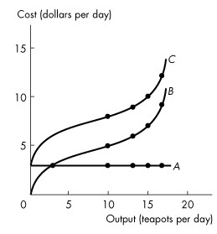
- Refer to the above Figure, which one of the following statements is false?
  - The total fixed cost curve is A.
  - Total variable cost and total cost both increase with output.
  - The vertical gap between curves B and C is equal to total variable cost.
  - Marginal cost is equal to the slope of curve C.
  - Total fixed cost is constant.
Answer: C
- With respect to water and diamonds, water
  - has a higher marginal utility.
  - has a lower marginal utility.
  - has a lower total utility.
  - is cheaper than diamonds because it has a lower total utility.
  - none of the above.
Answer: B
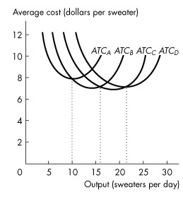
- Refer to the above figure, which illustrates the short-run average total cost curves for four different plant sizes. Which plant has the lowest average total cost for an output rate of 5 sweaters a day?
  - Plant A
  - Plant B
  - Plant C
  - Plant D
  - none of the above
Answer: A
- When a market price allocates a scarce resource
- everyone in the economy can use the resource.
- only those who show interest can use the resource.
- willingness-to-pay is not an issue.
- ability to pay for the resource is less important than willingness-to-pay.
- only those who are willing and able to pay get the resource.
Answer: E
- The first-come, first-served method of resource allocation allocates resources to
  - the wealthiest.
  - people who are willing to take risks.
  - people who are not willing to take risks.
  - the first in line.
  - honest, hard-working people.
Answer: D

- A new car has a sticker price of $35,000. Fred decided that he would pay no more than $32,000 for this car. He bought the car for $31,000. Fred obtained a consumer surplus of
- $35,000.
- $32,000.
- $4,000.
- $3,000.
- $1,000.
Answer: E
Use the figure below to answer the following questions.

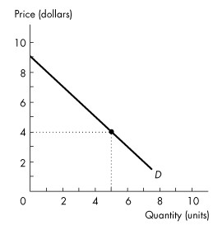
Figure 5.2.1

- Consider the demand curve in Figure 5.2.1. If the price of the good is $4, what is the consumer surplus?
- $32.50
- $25.00
- $20.00
- $12.50
- none of the above
Answer: D
- When the efficient quantity is produced
- total consumer surplus is zero.
- total producer surplus is zero.
- consumer surplus exceeds producer surplus by the greatest possible amount.
- producer surplus exceeds consumer surplus by the greatest possible amount.
- the sum of consumer surplus and producer surplus is maximized.
Answer: E
Use the figure below to answer the following questions.

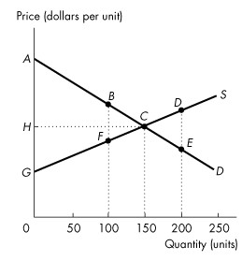
Figure 5.4.2

- Refer to Figure 5.4.2. If the level of output is 150 units, the producer surplus is area
- BCF.
- ACG.
- DCE.
- ACH.
- HCG.
Answer: E
- Refer to Figure 5.4.2. If the level of output is 100 units, the deadweight loss is area
- BCF.
- ACG.
- DCE.
- ACH.
- HCG.
Answer: A
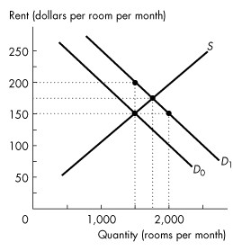
- Refer to the above Figure. If the demand for rental housing increases and the demand curve shifts rightward from D0 to D1, and there is a strictly enforced rent ceiling of $150 per room,
  - the number of rooms rented will increase to 2,000.
  - the number of rooms rented is 1,500.
  - there is a housing shortage of 500 rooms.
  - both B and C.
  - the number of rooms rented decreases to 1,000.
Answer: D

- Complete the following sentence. A price floor set below the equilibrium price results in
  - a surplus.
  - a shortage.
  - the equilibrium price.
  - an increase in supply.
  - a decrease in demand.
Answer: C
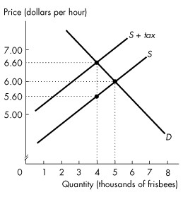
- Refer to the above Figure, showing the market for frisbees before and after a tax is imposed. The tax on each frisbee is
  - $0.40.
  - $0.60.
  - $1.00.
  - $5.60.
  - $6.60.
Answer: C

- Refer to the above Figure, showing the market for frisbees before and after a tax is imposed. On each frisbee, the sellers' share of the tax is
  - $0.40.
  - $0.60.
  - $1.00.
  - $5.60.
  - $6.60.
Answer: A
- Utility is
A) the value of a good.
B) the additional satisfaction received from consuming another unit of a good.
C) the benefit or satisfaction from consuming goods and services.
D) the practical usefulness of a good.
E) equal to the price of a good.
Answer: C
Section II (20 marks). PROBLEM SOLVING (Please show your steps)
- (10 marks) Following table gives Amy’s utility from the consumption of popcorn and candy bars during a week.
Bags of popcorns | Total utility for popcorn | Marginal Utility | Number of candy bars | Total utility for candy bars | Marginal utility
1 | 20 | 20 | 1 | 14 | 14
2 | 36 | 16 | 2 | 26 | 12
3 | 50 | 14 | 3 |  | 10
4 |  | 12 | 4 | 44 | 8
5 | 72 | 10 | 5 | 51 | 7
6 | 80 | 8 | 6 | 57 | 6

a. Suppose Amy’s weekly allowance is $4, the price of a bag of popcorn is $1 and the price of a candy bar is $0.50. How much popcorn and how many candy bars will Amy consume each week if she maximizes her utility? (Use marginal analysis).

Popcorn | MU | MU/P | Candy | MU | MU/P
1 | 20 | 20 | 6 | 6 | 12
2 | 16 | 16 | 4 | 8 | 16
3 | 14 | 14 | 2 | 12 | 24

Amy will consume 2 bags popcorns and 4 candy bars.

b. Suppose the price of a candy bar doubles to $1, the price of popcorn remains the same. How much popcorn and how many candy bars will Amy consume each week if she maximizes her utility? (use marginal analysis).
Popcorn | MU | MU/P | Candy | MU | MU/P
1 | 20 | 20 | 3 | 10 | 10
2 | 16 | 16 | 2 | 12 | 12
3 | 14 | 14 | 1 | 14 | 14
Amy will consume 3 bags of popcorns and 1 candy bars.
2. (10 marks) Let’s examine the short-run costs of golf cart production. The first two columns of the table show the total monthly output of golf carts using varying quantities of labor. The cost of 1 labor (the only variable input) is $2,000 per month. Total fixed cost is $2000 per month.

Table 11.2 Short-Run Costs (Monthly)
Labors per month | Output (unit per month) | TFC($) | TVC($) | TC($) | MC($) | AFC($) | AVC($) | ATC($)
0 | 0 | 2,000 | 0 | 2000
1 | 1 | 2,000 | 2000 | 4000 | 2000 | 2000 | 2000 | 4000
2 | 3 | 2,000 | 4000 | 6000 | 1000 | 666.67 | 1333.33 | 2000
3 | 6 | 2,000 | 6000 | 8000 | 666.67 | 333.33 | 1000 | 1333.33
4 | 12 | 2,000 | 8000 | 10000 | 333.33 | 166.67 | 666.67 | 833.33
5 | 17 | 2,000 | 10000 | 12000 | 400 | 117.65 | 588.24 | 705.89
6 | 20 | 2,000 | 12000 | 14000 | 666.67 | 100 | 600 | 700
7 | 22 | 2,000 | 14000 | 16000 | 1000 | 90.91 | 636.36 | 727.27
8 | 23 | 2,000 | 16000 | 18000 | 2000 | 86.97 | 695.65 | 782.61

- Given this information, complete Table 11.2.
Answer: see table above.

- Now suppose that the price of a labor increases to $2,500 a month. Explain how the average variable cost and marginal cost curve change.
Answer: AVC and MC will increase, and average variable cost and marginal cost curve will both shift upwards.

- Suppose that the cost of labor is still $2,000 per month. Total fixed cost increases to $4000 a month. Explain how the average total cost and marginal cost curve change.
Answer: Fixed cost will only affect total cost, but not marginal cost. Therefore ATC will increase and MC unchanged. ATC curve will shift upwards, while MC curve remains the same.

