Geology and mineralization of Iron Mask Batholith
Adapted from a poster by J. Logan, M. Mihalynuk (BCGS) and T. Ullrich and R. Friedman (U.B.C.) (http://www.em.gov.bc.ca/mining/geolsurv/Publications/OpenFiles/OF2006-12/toc.htm)

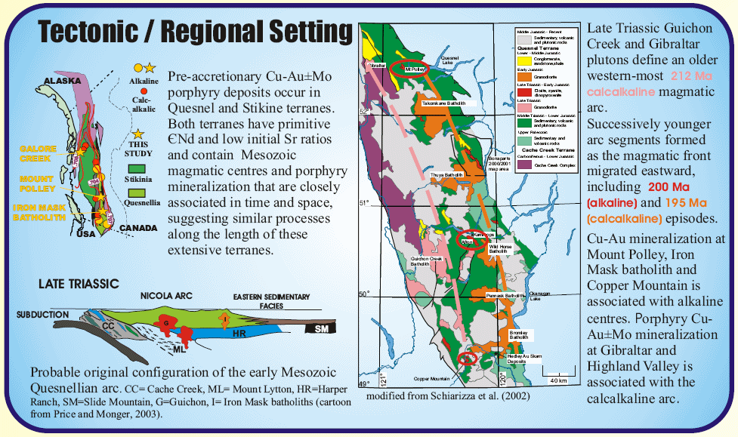
See next page for an enlargement of the geological map above

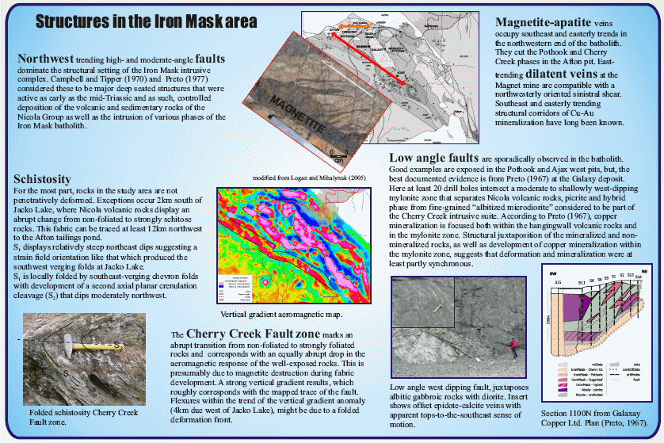
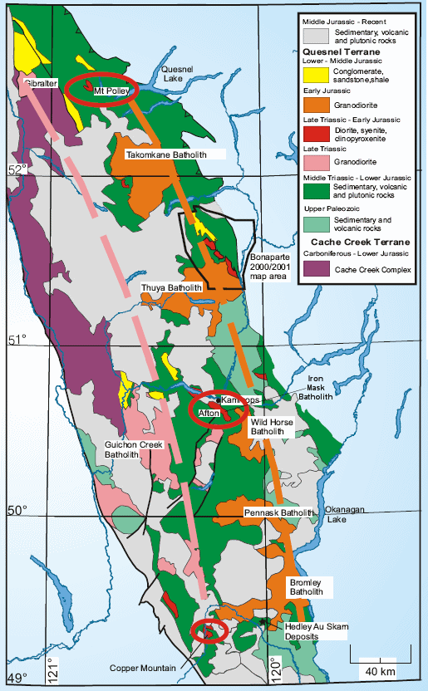

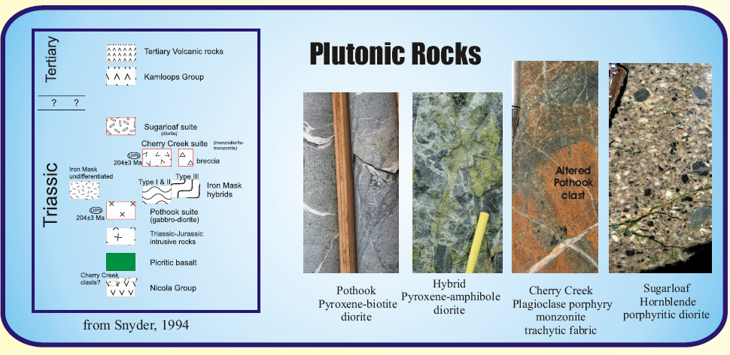

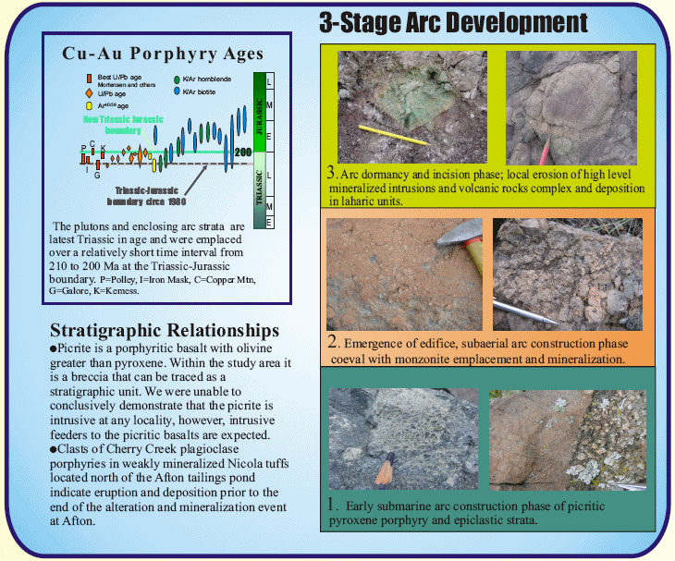

Mineral Deposits in the Iron Mask / Afton area – from Minfile report 092INE013

The Iron Mask batholith lies in the southern part of the Quesnel trough, also known as the Nicola belt. The most important pre-Tertiary rocks in this belt are Upper Triassic volcanic and sedimentary rocks of the Nicola Group. The batholith is a subvolcanic, multiple intrusion which is comagmatic and coeval with the Nicola rocks. It is situated along the southwest side of a regional northwest trending fracture zone and is itself cut by numerous northwesterly faults. The batholith comprises two major northwest trending plutons separated by 6 kilometres of Eocene Kamloops Group volcanic and sedimentary rocks. The Tertiary rocks occupy what appears to be a graben structure resulting from renewed fault movement around the margins of the plutons during Paleocene or Early Eocene time (Bulletin 77). The larger pluton, the 18 kilometre long southern part of the batholith, is called the Iron Mask pluton. The smaller Cherry Creek pluton farther northwest, outcrops on either side of Kamloops Lake. The combined exposure of the batholith, including the intervening younger rocks, is about 33 kilometres long and 5 kilometres wide. Sedimentary and volcanic rocks of the Kamloops Group unconformably overlie the Nicola rocks and the Iron Mask batholith. These include tuffaceous sandstone, siltstone and shale with minor conglomerate, as well as basaltic to andesitic flows and agglomerates with minor dacite, latite and trachyte.
In the vicinity of the batholith, the Nicola Group is dominated by volcanic and volcaniclastic sedimentary rocks. They are generally recognized by albitization of feldspars, occurrence of patchy epidote, and/or rare hematite alteration. On the southwestern flank of the Iron Mask pluton, well-indurated, massive and bedded tuff, breccia and interbedded flows and flow breccia are prominent and are weakly metamorphosed. On the northeast flank, less well-indurated and less altered tuff and tuff breccia predominate. However, adjacent to the intrusive contact, these rocks are also well indurated and epidotized and are locally mineralized with sulphides. At the southeastern tip of the Iron Mask pluton and locally along the southwestern flank, the Nicola rocks comprise distinctive porphyritic augite-hornblende basalt.
The Iron Mask pluton comprises four major, successively emplaced units designated as the Iron Mask Hybrid, Pothook, Sugarloaf and Cherry Creek units. Locally, an additional Picrite unit also occurs which is probably not genetically related to the batholith. The smaller Cherry Creek pluton consists entirely of the Cherry Creek unit. Isotopic dates (194 to 204 Ma +/- 6 Ma) indicate that all of these units are of Late Triassic or earliest Jurassic age (Bulletin 77).
The component units (except the Picrite unit) of the multiphase batholith are largely controlled by major systems of northwesterly, northerly and northeasterly trending fractures or faults. Most units show some degree of alteration and/or contamination which may be intense locally. Weak to moderate saussuritization is ubiquitous in all batholithic rocks while potassium feldspathization is more prominent in rocks of the Cherry Creek unit. The units are briefly described in order of oldest to youngest (determined mainly on crosscutting relationships).
The Iron Mask Hybrid unit forms the spine of the Iron Mask pluton. It is mostly agmatitic, consisting of rounded to angular fragments of various sizes, texture and composition in a dioritic matrix. The fragments include mainly coarse and fine-grained diorite and coarse-grained gabbro with lesser amounts of medium to coarse-grained hornblendite and scattered xenoliths of Nicola Group volcanic rocks. All rock varieties in the unit contain magnetite which is often more than 10 per cent by volume. Mineralization, particularly of iron and copper, is almost ubiquitous in this unit. The Iron Mask mine (092INE010), a former copper producer, is located in this unit, but is also associated with picrite.
The Pothook unit occurs mainly in the northwestern half of the Iron Mask pluton, appearing frequently as narrow, gradational zones between the Iron Mask Hybrid and Cherry Creek units. Rocks of this unit are uniformly of dioritic composition and are medium to coarse grained. The Pothook unit is locally mineralized with copper and iron.
The Picrite unit consists of rocks of basaltic composition with abundant clinopyroxene and serpentinized olivine phenocrysts. These rocks generally occur as steeply dipping, poorly exposed and relatively small lenticular bodies in many parts of the batholith. They appear to be associated with recurring, northwesterly trending fracture systems and copper mineralization frequently occurs in their vicinity. Because picrite basalt has been observed far from the two component plutons of the batholith, it is probable that this unit is not part of the batholith.
The Sugarloaf unit occurs mainly along the southwest side of the Iron Mask pluton and as small enclosed bodies in the southern half of the pluton. Rocks of this unit are mainly porphyritic with hornblende, minor clinopyroxene and plagioclase in a greyish green matrix. They are of fairly uniform diorite-andesite composition. Several copper occurrences are hosted by the Sugarloaf rocks. The Ajax deposit (West and East zones) east of Jacko Lake is located within brecciated and albitized Sugarloaf rocks.
The Cherry Creek unit is the most widely distributed phase of the batholith. It constitutes the entire Cherry Creek pluton. The unit consists of rocks with composition ranges from diorite, monzonite, syenite to their porphyritic and fine-grained equivalents as well as local intrusive breccias. Copper and minor iron mineralization is prominent in the Cherry Creek unit, particularly in zones of intense brecciation associated with alkali metasomatism. Afton mine (092INE023) lies at the western termination of a narrow, 4 kilometre long, easterly trending zone of intense intrusive brecciation that is located at the northern edge of the Iron Mask pluton.
On the Ajax (East) property, intrusive rocks are represented primarily by the Iron Mask Hybrid and Sugarloaf units. The Iron Mask Hybrid unit appears to have been emplaced as intrusive breccias cut and healed by mesocratic to leucocratic diorite. The younger Sugarloaf unit is directly associated with copper mineralization. It is typically a fine to medium-grained porphyritic diorite whose characteristic feature is a subparallel alignment of hornblende and augite phenocrysts. The bulk of this unit on the property seems to be from a single intrusive phase associated with the alteration and mineralizing events. However, at least one phase of post-ore, very fine-grained microdiorite is observed in drill core. This phase has little or no copper mineralization and occurs as bodies of limited size and extent, most notably in the hanging wall area of the West zone (092INE012). The Picrite unit has been noted in drill core.
Sodium metasomatism (albitization) is widespread and has caused extensive alteration of both Sugarloaf and Iron Mask Hybrid rocks. The degree of alteration ranges from minor fracture envelopes to total replacement of the original minerals resulting in a brittle, hard, porcellaneous white rock composed largely of secondary albite. Albitization is most intense in the contact area between Sugarloaf and Iron Mask Hybrid units. In detail, however, the albitized zones are variable, transitional and difficult to correlate between sections. Albitization as well as epidote-chlorite-carbonate alteration are important in the mineralized zones.
Volcanic rocks of the Nicola Group underlie the south portion of the property. Close to the intrusive contact the rocks consist primarily of andesitic flows. Toward the southeast boundary tuffs are dominant. The Nicola rocks can be weakly albitized and cut by rare potassium feldspar veinlets but are never mineralized to ore grades.
At the Ajax East zone, located 1000 metres east-northeast of the Ajax West zone, mineralization occurs along the northeast trending and west dipping contact zone between Iron Mask Hybrid unit diorite to the northwest and the main lobe of Sugarloaf unit diorite to the south and east. Again, intense albite alteration is concentrated in the vicinity of the contact zone and affects both Sugarloaf and Iron Mask Hybrid rocks. Hydrothermal biotite is also abundant around the East pit area. Unique to the Ajax East zone is the presence of bands of very mafic to ultramafic rocks in the contact area. Drill core suggests they are intercalated with the Iron Mask Hybrid unit and are possibly a mafic or volcanic component of that unit. The occasional presence of serpentinized olivine suggests that the rocks might also be Picrite unit remnants sited on a deep-seated contact fault. The ultramafic rocks can be weakly albitized. This central contact area dips 40 to 50 degrees to the west-northwest and is strongly sheared and brecciated. Iron Mask Hybrid and Sugarloaf units become more massive and less altered away from the contact area. Copper mineralization is localized about the contact but occurs predominantly in the footwall Sugarloaf rocks and is bounded by stronger pyrite mineralization on the east.
Distribution of mineralization is similar to the Ajax West zone (see 092INE012) being a combination of disseminations and fracture- fillings. However, trench mapping indicated that north trending fracture and joint sets with steep westerly dips may be preferentially mineralized. Other known but less persistent mineralized zones occur to the southeast in an en echelon fashion and fall outside the initial East zone pit. At the north end of the Ajax East zone, the Iron Mask Hybrid unit and included ultramafic rocks expand to the north and east, cutting off both the Sugarloaf unit diorite and the copper mineralization.
In both the Ajax West and Ajax East zones, chalcopyrite is the predominant copper mineral and the only one of economic significance. It occurs as blebs and disseminations, in fractures, veinlets and microveinlets, and occasionally in breccias and vugs with accompanying calcite. Pyrite is ubiquitous; it occurs with chalcopyrite in similar proportions but also exists separately, notably peripheral to copper mineralization. Overall pyrite content does not exceed 1 to 2 per cent. Bornite and chalcocite are present in trace amounts only. Malachite and azurite are noted in outcrop areas with spotty distribution at depth. Leaching and removal of copper have been minimal. Alteration tends to be spotty and incomplete with pyrite and chalcopyrite present as well.
Molybdenite occurrences are widespread but values are generally quite low. Magnetite is present primarily as disseminations; large scale magnetite veining is absent. Gold mineralization is closely associated with chalcopyrite mineralization. Except in rare cases, gold values do not occur on the Ajax property except in conjunction with copper mineralization. Gold-copper ratios do vary however. Only one phase of mineralization is present in the East zone but in the West zone several pulses are indicated by the spatial distribution of copper-gold ratios.
Measured recoverable reserves for a two-stage West pit and a single stage East pit are as follows (Assessment Report 17199):
--------------------------------------------------------
Pit Tonnes Cu % Au g/t
Stage 1 West 3,847,011 0.57 0.41
Stage 2 West 14,473,687 0.44 0.30
Total West 18,320,698 0.47 0.34
East 6,366,027 0.44 0.34
Total Reserves 24,686,725 0.46 0.34
---------------------------------------------------------
Mining of the Ajax deposit began after the depletion of economic open pit reserves at Afton in early 1989 (see Afton, 092INE023).
In June 1989, mining commenced at the Ajax deposit (West and East pits), 10 kilometres to the south-southeast of the Afton open pit. Ore is hauled via a new road to the Afton mill complex. The Ajax mining operations ceased in August 1991. See Afton (092INE023) for production figures.
Afton Operating Corporation, a subsidiary of Teck Corp., resumed production in September, 1994 after a three-year suspension in operations because of depressed metal prices. Production from the Ajax East pit, which contained approximately 3.63 million tonnes of ore grading 0.46 per cent copper and 0.34 gram per tonne gold, totalled 3600 tonnes of copper and 245 kilograms of gold from 931,000 tonnes milled at a daily throughput of 8700 tonnes. Reserves for the Afton-Ajax deposits estimated by the company at January 1, 1995 were 13.2 million tonnes grading 0.42 per cent copper and 0.34 gram per tonne gold (Information Circular 1996-1, page 7).
In 1995, Afton announced that it would re-open the Ajax West pit (092INE012), with about 9 million tonnes of the same grade as Ajax East, extending the mine life from December 1996 to about December 1998. Pushback stripping of the Ajax West pit began, and ore was milled (Information Circular 1996-1, page 7). See Ajax (West) (092INE012) .
Production in 1995 from the Ajax East pit totalled 11,824 tonnes of copper, 830 kilograms of gold and 1559 kilograms of silver from 2,928,922 tonnes milled at a daily throughput of 8770 tonnes. During 1996, mining took place in the Ajax West pit; much of the Ajax East pit was backfilled with waste from the West pit. Closure of the West pit operation was June 1997 due to low copper prices and the low grade of the remaining ore.
This property extends easterly from Jacko Lake, about 9 kilometres southwest of Kamloops. The Ajax claim (Lot 4710) is located about 500 metres east of the lake; the Wheal Tamar claim (Lot 2126) is located 2000 metres east northeast of the Ajax; the Monte Carlo (Lot 4176, 092INE014)is about 500 metres east of the Wheal Tamar. The first report of underground exploration work on the Wheal Tamar claim was in 1898. The claim was at that time owned by O.S. Batchelor and the Boillot Bros. By 1904, three groups of claims had been located. These were the Wheal Tamar, Tamar Fraction, Blizzard Fraction; the Monte Carlo, Sultan, Anaconda, Whitecap Fraction; the Ajax, Hercules, Jupiter, Neptune, Mars. The first development work reported on the Monte Carlo was in 1905, and on the Ajax in 1906. The Kamloops Queen, located adjacent to the Wheal Tamar claim in 1908, subsequently lapsed. The Wheal Tamar and Forlorn (Lot 3016) claims were Crown granted to O.S. Batchelor in 1912 and 1916 respectively. The Granby Consolidated Mining, Smelting and Power Company, Limited optioned the Wheal Tamar group in 1916 and carried out diamond drilling, but the results of this work are not recorded. Ownership of the Monte Carlo and Ajax groups was not recorded, other than that G.J. Rogers, of Knutsford, owned the Monte Carlo in 1913 and acquired the Ajax prior to 1923. Exploration work was carried out on an annual basis to 1914, and sporadically thereafter. The original workings on the Wheal Tamar include 6 shafts and an adit; in 1909 the adit was 143 metres long and shafts and adit totalled over 213 metres. The Monte Carlo workings included an adit, and a shaft said in 1924 to be 18 metres. The Ajax was explored by two adits. The Consolidated Mining and Smelting Company of Canada (Limited) (Cominco Ltd. since 1966) optioned 13 claims in the Ajax and Monte Carlo groups from Mr. Rogers late in 1928. Diamond drilling during 1929 was done in 10 holes on the Ajax group. The results indicated sparse mineralization in a zone approximately 76 metres wide and trending 295 degrees with steep dips to the north. On the Monte Carlo, 27 metres of drift was driven, and 243.8 metres of diamond drilling was done in 3 holes. Berens River Mines Limited in 1952 held an option on several of these claims. Diamond drilling was done in 4 holes midway between the Wheal Tamar and Monte Carlo claims. No mineralization was encountered and the option was dropped. Cominco Ltd. resumed work on the property in 1954. The company at that time held 4 Crown grants under lease and 16 full and fractional claims. A number of claims were subsequently acquired until in 1967 the property comprised the Jacko group of recorded claims and 8 Crown grants including, in addition to those mentioned above, the Copper Star (Lot 3015), Grass Roots (Lot 1496), Sultan (Lot 4717), and Neptune (Lot 4712). An electromagnetic survey was carried out in 1954 and further geophysical work was reported in 1958, and in 1967 (magnetometer survey). Diamond drilling by Cominco to the end of 1967 totalled over 7620 metres in 56 holes. Most of this drilling has been concentrated on the Ajax showings. Drilling was reported in 1967 on the Wheal Tamar and Monte Carlo showings. Drilling to 1967 is reported to have developed 9,710,000 tonnes grading 0.5 per cent copper (Prendergast, J.B., Summary Report on Property of Pinnacle Mines Ltd., January 30, 1969). No further activity was reported until 1973 when exploration work carried out by Attan Mines Ltd. included an induced polarization survey over 15.1 line kilometres, and percussion drilling in 28 holes totalling 2197.6 metres on the Ajax, 23 holes totalling 2103.1 metres on the Wheal Tamar, and 4 holes totalling 365.7 metres on Jacko 10 Fr. Seven holes drilled in 1973 and 1980 outlined a "reserve" of 5.9 million tonnes grading 1.55 per cent copper, 1.6 grams per tonne gold and 6.86 grams per tonne silver (Afton Annual Report, 1980). One hole intersected 2.5 per cent copper and 1.06 grams per tonne gold over 200 metres. Another hole assayed 3.3 per cent copper over 85 metres, including 5.6 per cent copper over 32 metres. The mineralization is in hypogene (sulphides) and has a true width of approximately 90 metres. In 1980, Cominco Ltd. carried out magnetometer and induced polarization surveys over 66 kilometres and 14,347 metres of percussion drilling in 190 holes; E&B Canada Resources Ltd. provided $1,000,000 in financing for this project, thereby earning a 6 per cent interest in the property; E&B was subsequently acquired by Imperial Metals Corporation. Drill indicated reserves were reported at 95,245,500 tonnes grading 0.32 per cent copper, 0.27 gram per tonne gold (Joint Management Information Circular, Royex Sturgex Mining Limited and Cullaton Lake Gold Mines Ltd., April 27, 1984). Teck Corporation and Metall Mining corporation, through Afton Operating Corporation, in November 1986 obtained an option to earn a 70 per cent interest from owners Cominco Ltd. and Imperial Metals Corporation. Work by Teck in 1987 included 11,582 metres of diamond drilling in 77 holes. Reserves were reported as 95,245,500 tonnes at 0.51 per cent copper equivalent (Imperial Metals, 1987 Annual Report) or 24,673,120 tonnes at 0.46 per cent copper, 0.34 gram per tonne gold (Imperial Metals, 1988 Annual Report). Work in 1988 included development of the East (092INE013) and West (092INE012) open pits, and construction of a haul road to transport the ore to the Afton mill, some 10 kilometres to the northwest. In 2001, DRC Resources Corporation conducted geological mapping and 0.6 kilometre of ground magnetic survey.
Bibliography

EMPR BULL 77

EMPR EXPL 1980-235; 1996-D6; 1997-34; 2001-38

EMPR FIELDWORK 1974, pp. 22-26; 1976, pp. 41-46;
1977, pp. 37,38, 86- 88; 1982, pp. 267-284; 2002, pp. 129-132

EMPR GEM 1973-197

EMPR INF CIRC 1994-19, p. 8; 1995-9, p. 7; 1996-1, p. 7; 1997-1, p. 9

EMPR MAP 26; 48; 65 (1989)

EMPR PF ((see Ajax property file - 092INE012, Imperial Metals
Corporation Annual Report 1989; News Release - Feb.2, 1989; Drill hole location maps, drill section, geology maps, magnetometer and induced polarization maps))

EMR MP CORPFILE (Imperial Metals Corporation; Teck Corporation; Metall Mining Corporation)

GSC OF 165; 980; 2490

GSC MAP 886A; 887A; 9-1963; 1394A; 42-1989

GSC MEM 249

GSC P 44-20; 82-1A, pp. 293-297; 85-1A, pp. 349-358; 93-1A, pp. 87- 95
CIM Special Volume 46, pp. 565-580

Cann, R.M. (1979): Geochemistry of Magnetite and
the Genesis of Magnetite-apatite Lodes in the Iron Mask Batholith,
B.C. Unpub. M.Sc. Thesis, University of British Columbia
Northern Miner, Nov.10, 1997

Teck Corporation, Annual Report 1996

