Tulameen road cut fossil locality*

Access: Large roadcut on Tulameen Rd, 6.3 km west of Tulameen River Bridge at Princeton

Description: roadcut is ~30m high. Extensive talus of paper shale covers lower part. About 10 m of varicoloured fine sandstone, ash and coal crops out as the upper part. Much of shale is hard, compact, purple and siliceous. Dips 30º E.

Formation and age: Allenby Fm., Eocene, Lacustrine (thick volcanic rocks that underlie the Allenby Fm. are exposed a few hundred m down the road)

Fossils: Metasequoia and deciduous leaves predominate (Alnus, Amenotaxus, Betual, Comptonia, Corylus, Decodon, Fagopsis, Florissantia, Ginko, Langeria, Macginitea, Paleocarpinus, Purnus, Pseudolarix, Rhus, Sassafras and Sequoia) Fish fragments and bones are reported (incl. Eohiodan and Eosalmo) Insects: Diptera, Coleoptera (Curculionidae), and Homoptera.

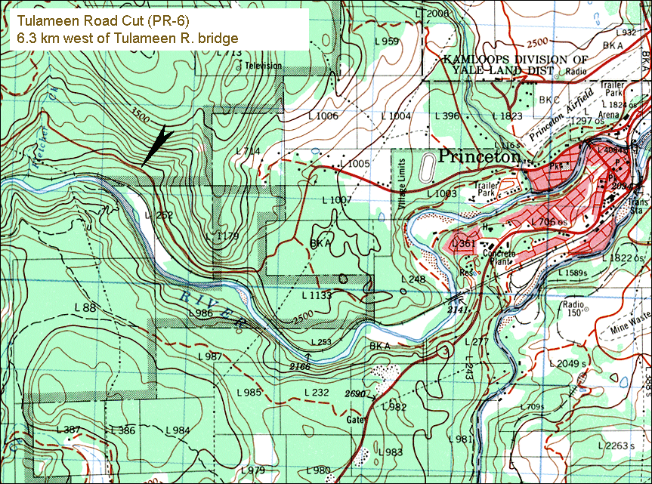

* extracted from: Ludvigsen, 1996, Fossil Sites in the Kamloops Region, RBCM

