Horseshoe Canyon Formation in the Drumheller area

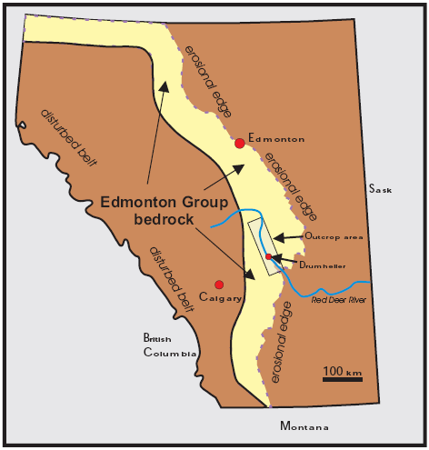
The Horseshoe Canyon Fm. (part of the Edmonton Gp.) is an Upper-Cretaceous (same age as the upper part of the Nanaimo Gp.) clastic unit that extends north to south through Alberta. According to Tyrell Museum geologist Dave Eberth, the HCF represents the beginning of the regressive phase that marked the end of the Western Interior Seaway. In other words, while the central part of North America was flooded with shallow seas throughout most of the Paleozoic and much of the Mesozoic, those waters started to subside once and for all in the Late Cretaceous (why?), and these rocks show that transition.

We will look at lower HCF rocks at a number of locations in the Red Deer Valley, extending from Dorothy in the southeast to Drumheller in the northwest. We will see the underlying marine Bearpaw Fm. and the brief marine incursion represented by the Drumheller Marine Tongue, but mostly we will focus on the shoreface, estuary, tidal flat, swamp, and fluvial deposits that are characteristic of the HCF.

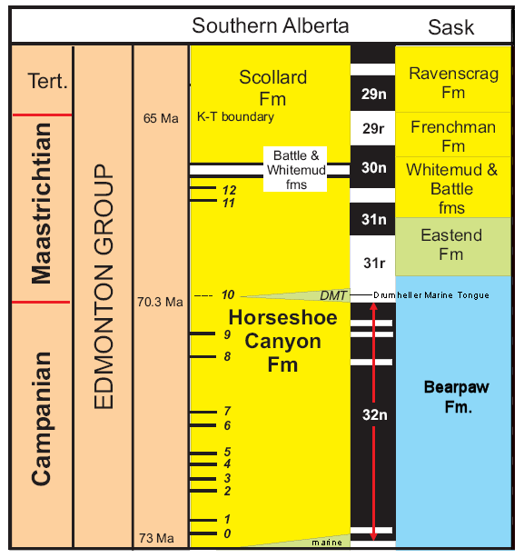
This document is based on a field trip guide written by Dave Eberth for a private tour given to Petro Canada Geologists in 2004. I can lend that field guide to anyone who is interested.

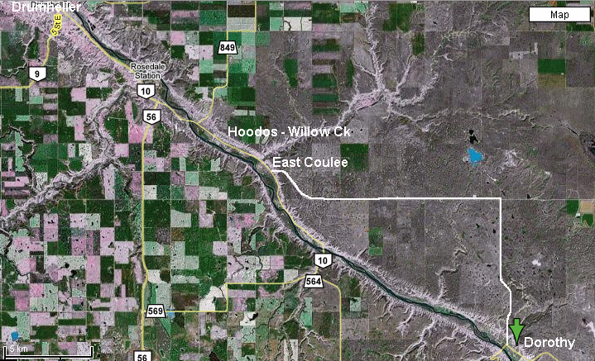

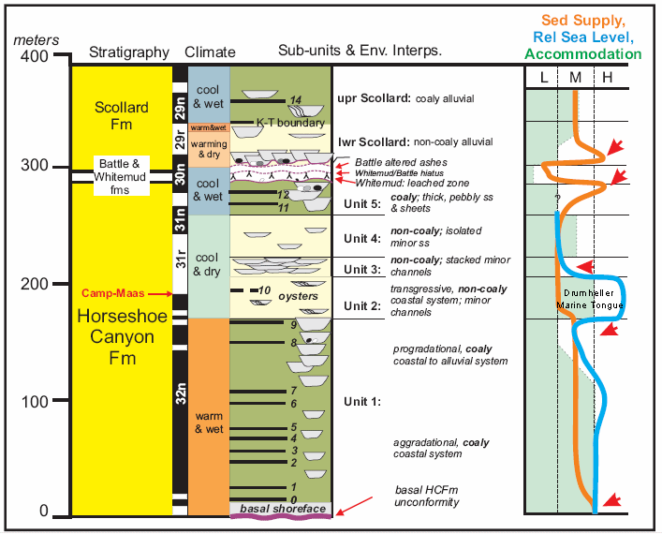

Dorothy (SB=sequence boundary, FS=flooding sequence)

Things to look for: Bentonite layer (what is the origin?) Plane beds and hummocky cross-stratification. Trace fossils and other fossils (marine or terrestrial?) Fining upward and coarsening upward sequences.

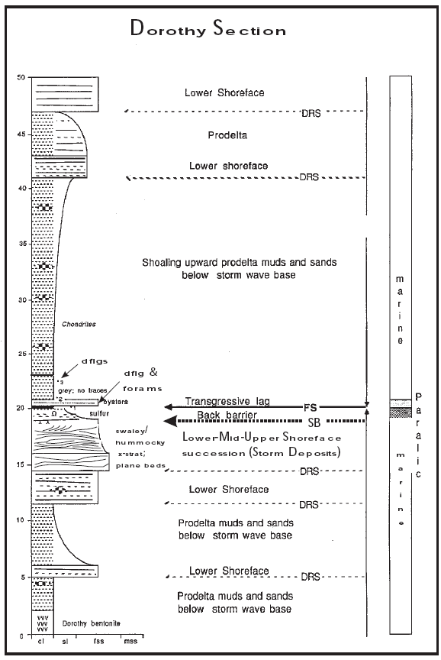
East Coulee (SB=sequence boundary, FS=flooding sequence)

Things to look for: Marine to terrestrial transition (sharp or gradational?) Hummocky cross strat. Rip-up clasts. Roots. Coal 0, 1 and 2. Cross bedding. A mud-filled channel. (What does this represent?)

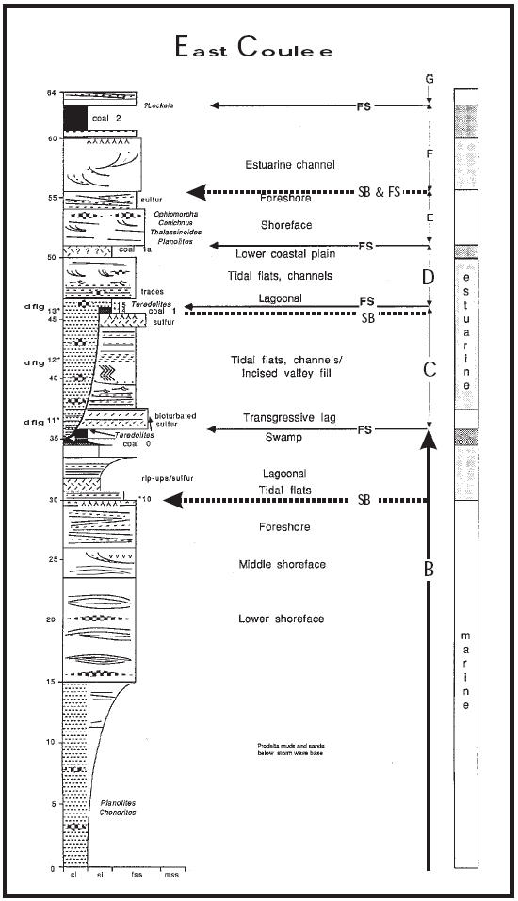

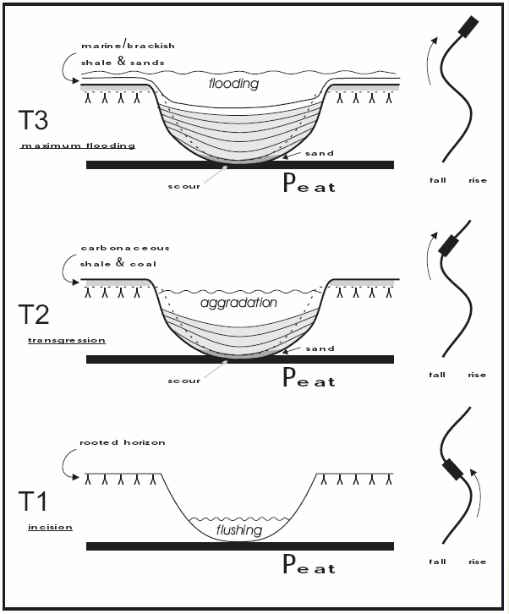

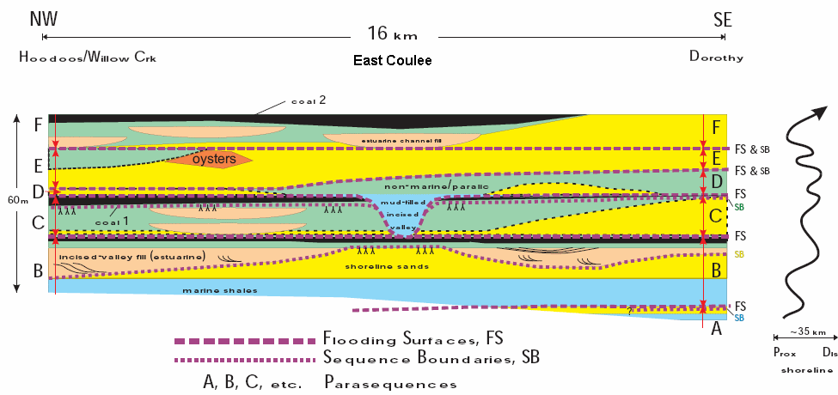

Hoodoos – Willow Creek

Look for: Marine-terrestrial transition (gradational or sharp?), cross-bedding. inclined heterolithic strata (what is it, and what does it tell us?)

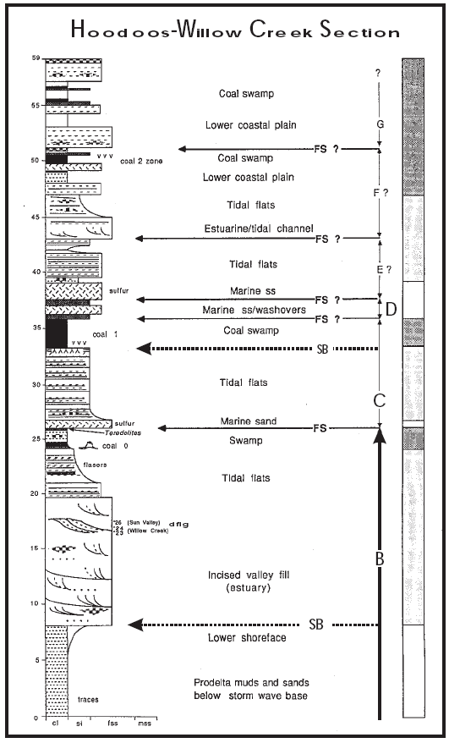
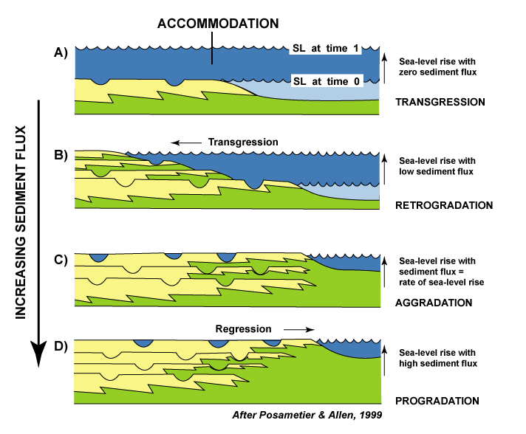

Source:

Eberth, D A, 2004, Revised Stratigraphy of the Edmonton Group (Upper Cretaceous) in the Bearpaw-Horseshoe Canyon transition, (for: PetroCanada Field Trip, October 2004).

(This document is copyrighted and all of the figures reproduced above are the property of D. Eberth and Royall Tyrell Museum)

